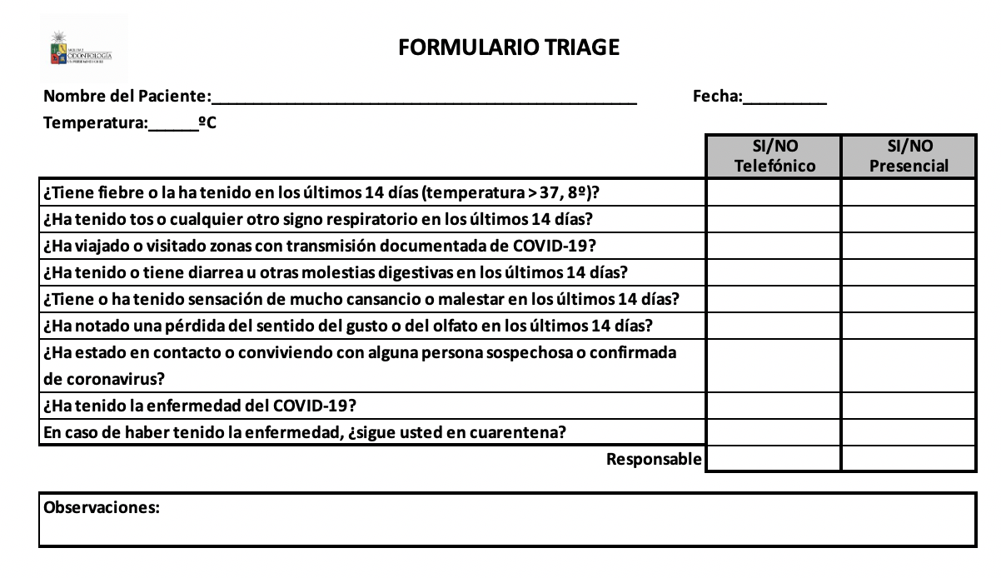

**FORMULARIO TRIAGE ESTATUS COVID-19**