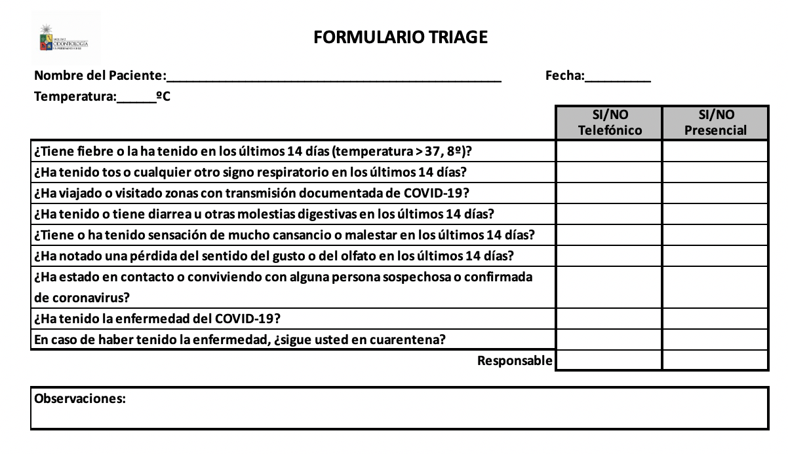

**FORMULARIO TRIAGE ESTATUS COVID-19**



**FORMULARIO TRIAGE ESTATUS COVID-19**