 Review for Integrated Test
Beginner Level 2024-2
I. Answer these questions.
- How are you today?
__________________________________________________________
- How old is the person next to you now?
__________________________________________________________
3. What does a nurse do every day?
__________________________________________________________
4. How tall are you?
____________________________________________________________
5. What are you doing now?
____________________________________________________________
- What are you going to do next Sunday?
___________________________________________________________
- How old are you?
____________________________________________________________
- What does a health professional do every day?
___________________________________________________________
- What are you wearing at the moment?
__________________________________________________________
- Unscramble these sentences. Consider grammar changes if necessary.
  - My / study/ classmates/ chemistry / never ___________________________________
  - Carolina/ her/ friend /evening/ meeting/ this/ is _______________________________
  - Stephany / everyday/the library/ eat / in ____________________________________
  - coffee / I / in the morning / drink / usually ___________________________________
  - José / alcohol / hate / and /coffee _________________________________________
  - sport / play / does /any / she /every day /?/ __________________________________
  - the newspaper / read /you / do? /on line _________________________________
- Write the questions to the following answers.
  - ___________________________________________________________________?
I feel cold this evening.
  - ___________________________________________________________________?
My classmate is 20 years old.
  - ___________________________________________________________________?
Jaime is studying medicine at the University of Chile.
  - ___________________________________________________________________?
I do not have a computer at home.
  - ___________________________________________________________________?
We always study in the library.
  - ___________________________________________________________________?
My parents are traveling to the South next week.
  - __________________________________________________________________?
No, I don't.

- Write the numbers in words:
  - 1555 ___________________________________________________________
2. 1907 ___________________________________________________________
  - 1.000.000 ___________________________________________________________
  - 618 ____________________________________________________________
  - 44 ____________________________________________________________
  - 222 ____________________________________________________________
  - 2012 ____________________________________________________________

IV.- The Faculty of Medicine at the University of Chile offers various career paths and programs in the field of medicine. Match the definitions with the corresponding subject.

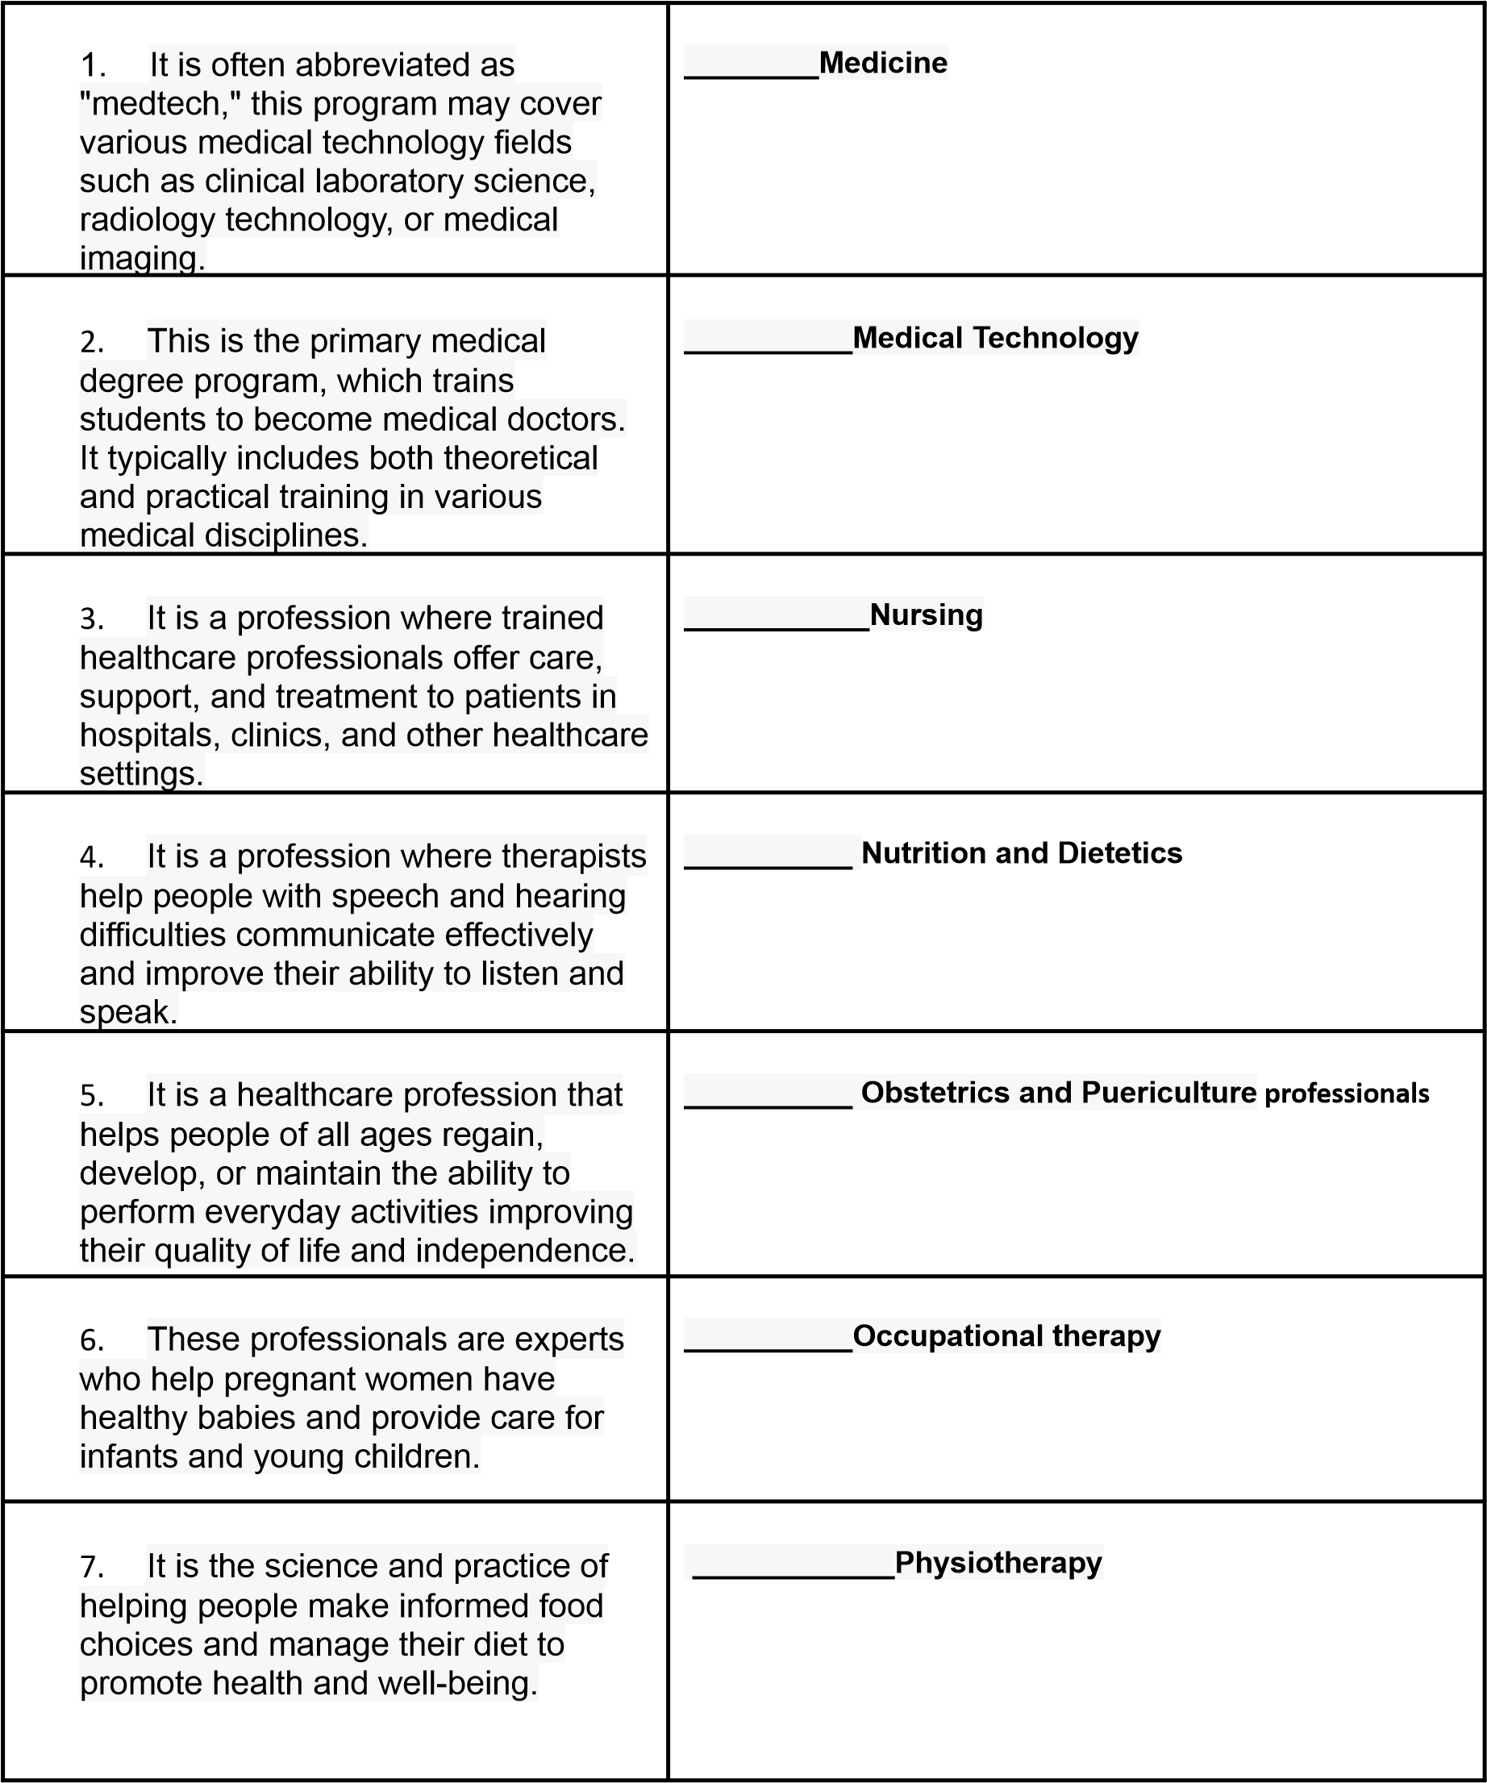
8. This profession helps people move better and reduce pain through exercises and physical treatments. | __________Speech and Hearing Therapy

- Write about 40 words about your daily routine. Use some adverbs of frequency.

always – regularly – normally – usually – often – sometimes – rarely – hardly ever
____________________________________________________________________________________
____________________________________________________________________________________
____________________________________________________________________________________
____________________________________________________________________________________
____________________________________________________________________________________
____________________________________________________________________________________
____________________________________________________________________________________
_________________________________________________________________________________

