 **Review for Integrated Test**

**Beginner Level 2024-2**

**I. Answer these questions.**

1. How are you today?

__________________________________________________________

1. How old is the person next to you now?

__________________________________________________________

3. What does a nurse do every day?

__________________________________________________________

4. How tall are you?

____________________________________________________________

5. What are you doing now?

____________________________________________________________

1. What are you going to do next Sunday?

___________________________________________________________

1. How old are you?

____________________________________________________________

1. What does a health professional do every day?

___________________________________________________________

1. What are you wearing at the moment?

__________________________________________________________

1. **Unscramble these sentences. Consider grammar changes if necessary.**
   1. My / study/ classmates/ chemistry / never ___________________________________
   2. Carolina/ her/ friend /evening/ meeting/ this/ is _______________________________
   3. Stephany / everyday/the library/ eat / in ____________________________________
   4. coffee / I / in the morning / drink / usually ___________________________________
   5. José / alcohol / hate / and /coffee _________________________________________
   6. sport / play / does /any / she /every day /?/ __________________________________
   7. the newspaper / read /you / do? /on line _________________________________
2. **Write the questions to the following answers.**
   1. ___________________________________________________________________?

I feel cold this evening.

* 1. ___________________________________________________________________?

My classmate is 20 years old.

* 1. ___________________________________________________________________?

Jaime is studying medicine at the University of Chile.

* 1. ___________________________________________________________________?

I do not have a computer at home.

* 1. ___________________________________________________________________?

We always study in the library.

* 1. ___________________________________________________________________?

My parents are traveling to the South next week.

* 1. __________________________________________________________________?

No, I don't.

1. **Write the numbers in words:**
   1. **1555**  **___________________________________________________________**

**2. 1907 ___________________________________________________________**

* 1. **1.000.000 ___________________________________________________________**
  2. **618 ____________________________________________________________**
  3. **44 ____________________________________________________________**
  4. **222 ____________________________________________________________**
  5. **2012 ____________________________________________________________**

**IV.- The Faculty of Medicine at the University of Chile offers various career paths and programs in the field of medicine. Match the definitions with the corresponding subject.**

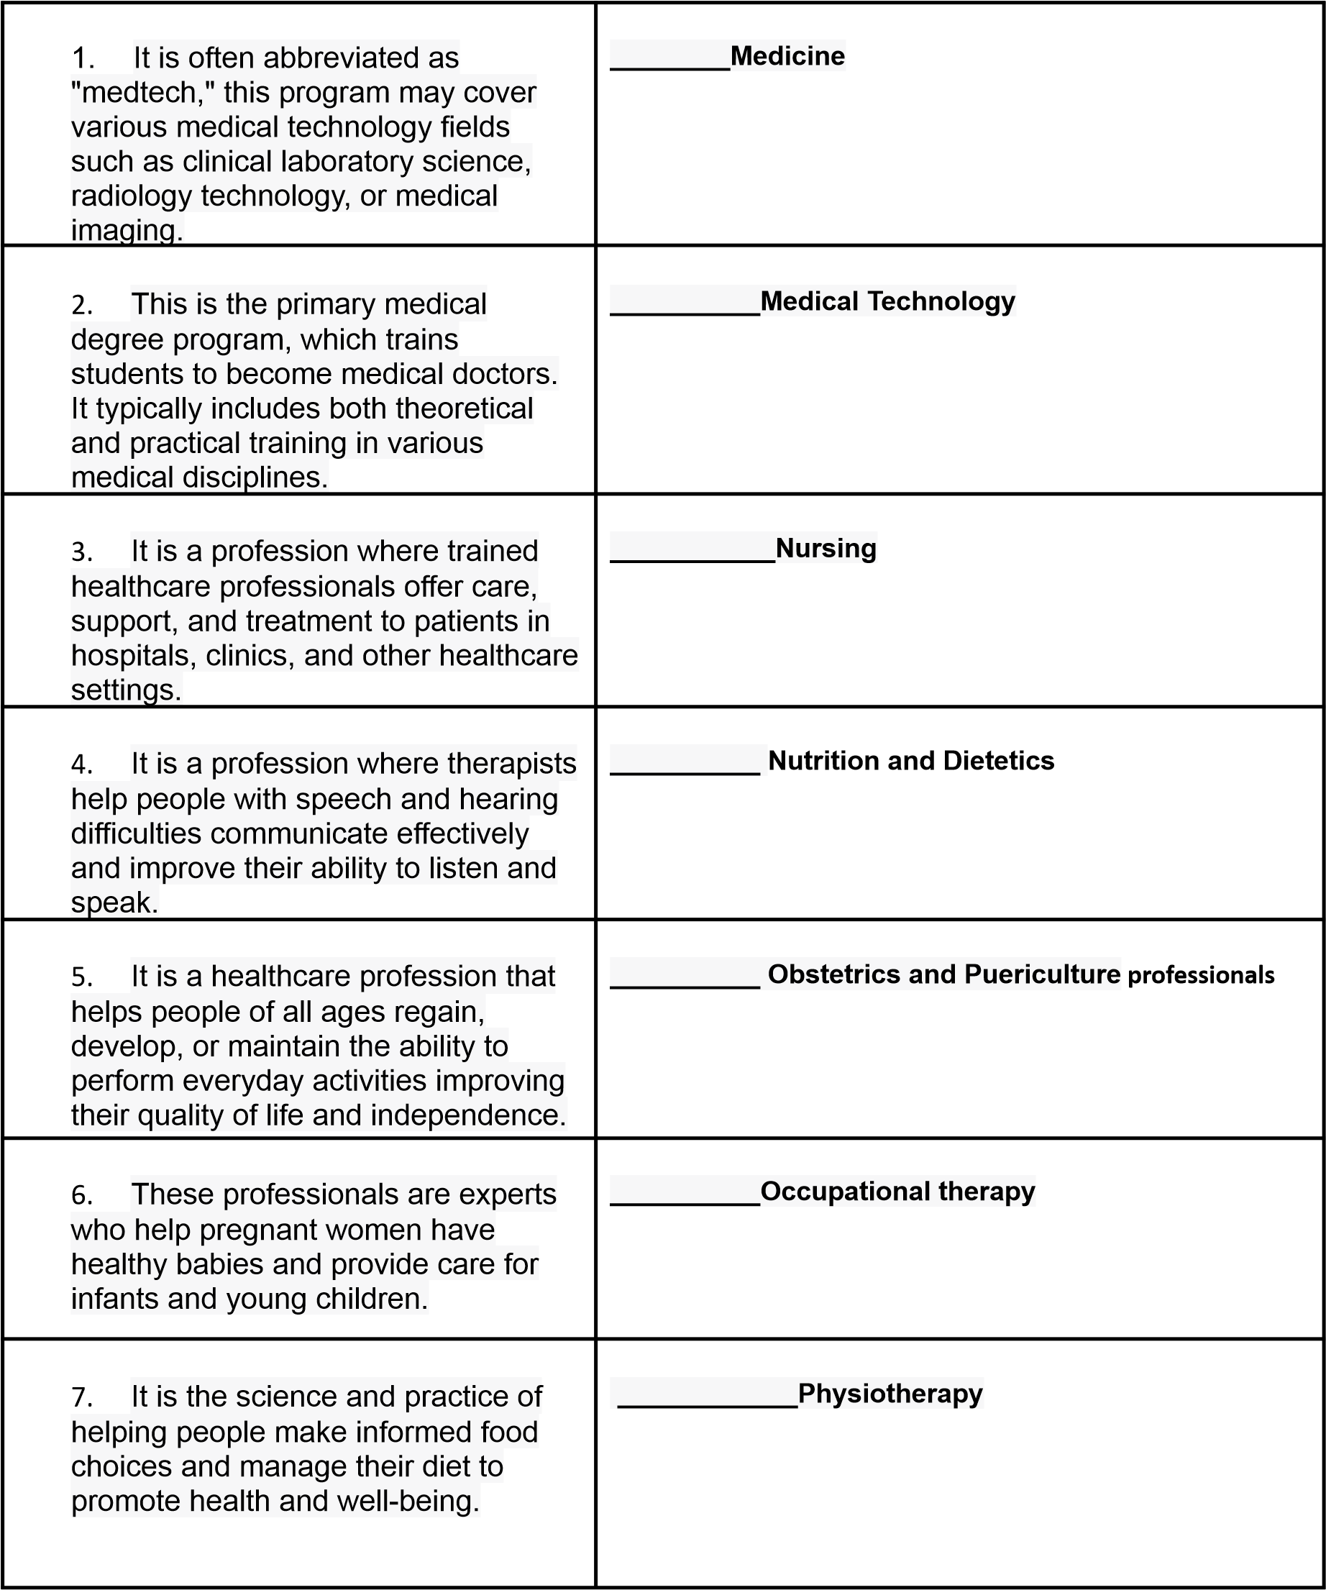

| 8. This profession helps people move better and reduce pain through exercises and physical treatments. | __________**Speech and Hearing Therapy** |
| --- | --- |

1. **Write about 40 words about your daily routine. Use some adverbs of frequency.**

| always – regularly – normally – usually – often – sometimes – rarely – hardly ever |
| --- |

**____________________________________________________________________________________**

**____________________________________________________________________________________**

**____________________________________________________________________________________**

**____________________________________________________________________________________**

**____________________________________________________________________________________**

**____________________________________________________________________________________**

**____________________________________________________________________________________**

**_________________________________________________________________________________**