

**SAMPLE QUIZ 2 EI2202**

Units 3A (out ex. 5 page 21), 3B (Out: Vocabulary Bank p.153 part 2), 6A (OUT: ex. 2, p.44 and ex. 4, page 45), 6B (OUT: page 46 and ex. 4, page 47) and 6C (OUT: page 49, ex. 5). Grammar and Vocabulary Banks.

**GRAMMAR**

**I. Spot the mistake. Decide if the sentences below are correct or wrong. Write the letter “C” next to the correct ones and letter “W” next to the wrong ones. Correct the wrong sentences to get the point.**

1. ______ Mmm… I don’t know what to do. Okay! I’m going with you.

________________________________________________________________________________________________________

2. ______ Look at his grades, he’s going to fail Chemistry.

________________________________________________________________________________________________________

3. ______ We’ll meet them at 10:30 at the museum.

________________________________________________________________________________________________________

4. ______ I think it will be easy to find a job after I graduate.

________________________________________________________________________________________________________

**II. Complete the following sentences with a verb from the box in the correct form.**

|  |
| --- |
| **to get – to hurt - to miss - to set – to lose – to push** |

1. We need to talk about the presentation, why don’t we ________________ a date for that?

2. I’m sorry I’m late, but I ________________ the bus and I had to wait a lot for the next one.

3. Could you please give me some paracetamol? My head ________________ a lot.

**III. Select the correct option a, b or c to complete the following sentences.**

1. When I opened the door, the children ______ a beautiful song. I was sorry to interrupt them. They had to start again.

a) sang b) was singing c) were singing

2. My daughter is really afraid ______ spiders. Whenever she sees one, she shouts and cries.

a) off b) of c) about

3. I ______ it again, now I know it was a mistake.

a) do b) won’t do c) ‘m not doing

**VOCABULARY**

**I. Write a synonym / similar expression from the ones learned in class to replace the underlined word (s). If it’s a verb make sure you use the right tense.**

1. Really? I can’t believe it! Please ***continue*** with the story.

________________________________________________________________________________________________________

2. I’m trying to ***contact*** Eva. Do you have her telephone number?

________________________________________________________________________________________________________

3. Yesterday the secretary ***reserved*** a big table at a five-stars restaurant.

________________________________________________________________________________________________________

**II. Fill in the gaps with a suitable word (S) from the ones learned in class. If it is a verb make sure you use it in the correct tense.**

1. My boyfriend usually **f**________________ with other girls. I can’t tolerate his attitude.

2. We can’t understand why he didn’t get the job, he is well **q**________________. He went to university and he has work experience.

3. They **s**________________ a lot of money on their trip to Asia. Now, they don’t have any money to fix the car.

**USE OF ENGLISH**

Based on the picture below, write FOUR lines about the woman’s dream. Mention the things or situations she dreamed about and what they mean to you. Grammar, vocabulary and spelling will be assessed.

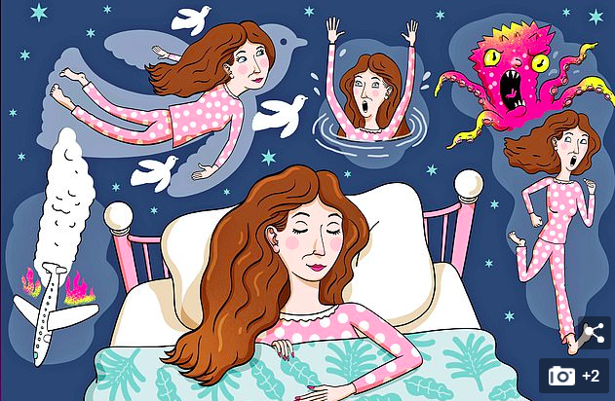

________________________________________________________________________________________________________________________________________________________________________________________________________________________________________________________________________________________________________________________________________________________________________________________________________________________________________________________________________________________________________________________________________

**Answer Key**

**GRAMMAR**

**I. Spot the mistake.**

1. W ... I’ll go with you. (instant decision)

2. C (Strong prediction with evidence)

3. W. We are meeting... (arrangement)

4. C (general prediction)

**II. Complete the sentences.**

1. set 2. missed 3. is hurting / hurts

**III. Multiple choice:**

1. c 2. b 3. b

**VOCABULARY**

**I. Synonyms:**

1. go on 2. get in touch with 3. booked

**II. Fill in the gaps:**

1. flirts 2. qualified 3. spent

**USE OF ENGLISH**

**Sample answer:**

*Last night Lily had a strange dream. She dreamed about flying with a group of white pigeons. I think this image represents Lily’s desire to be free of responsibilities. In fact, the responsibilities are embodied in a monster. She dreamed she was running away from a big pink octopus which I interpret as a symbol of her fear of failing her subjects at university.*