Past Simple and Past Perfect
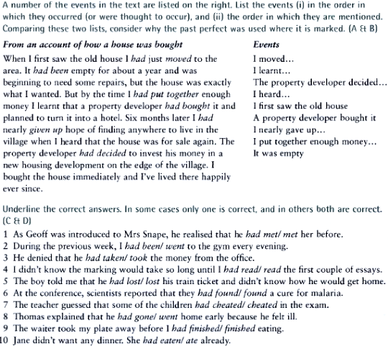

Past Simple, Present Perfect Simple and Continuous.

