Iron and Iron-Fe₃C Equilibrium Phase Diagram

Iron (Fe)
* Occurs naturally in meteorites. Only a small quantity is of terrestrial origin.
* Is the second most abundant metal (after aluminium) in the Earth’s crust. It constitutes about 95% of all the metal tonnage produced worldwide.
* Hardly ever found in the free (elemental) state. Exists mostly in combined states - iron ores.

Iron Ores
- Magnetite (Fe₃O₄) (black or blue iron oxide) - Limonite (2Fe₂O₃ + 3H₂O or FeO(OH).nH₂O)
- Haematite (Fe₂O₃) (red iron oxide or rust) - Siderite (FeCO₃)

Question: Which of these ores has the highest Fe content?

To obtain iron, iron ores are refined in either a blast furnace or a direct reduction furnace to remove impurities.

1. Blast Furnace Production of Iron

The figure below (Fig. 1) illustrates the process of producing iron from a blast furnace.
Iron Ore
Source of iron (mostly oxides of iron (e.g. Fe₂O₃) and silicon (SiO₂))
Coke
Source of carbon
Limestone (CaCO₃)
Removes impurities
(e.g. SiO₂)
Air
Blast Furnace
C + O₂ → CO₂
C + CO₂ → CO
Fe₂O₃ + 3CO → 2Fe + 3CO₂
Pig Iron
(Hot molten iron)

Fig. 1. Schematic illustration of iron production using a blast furnace.
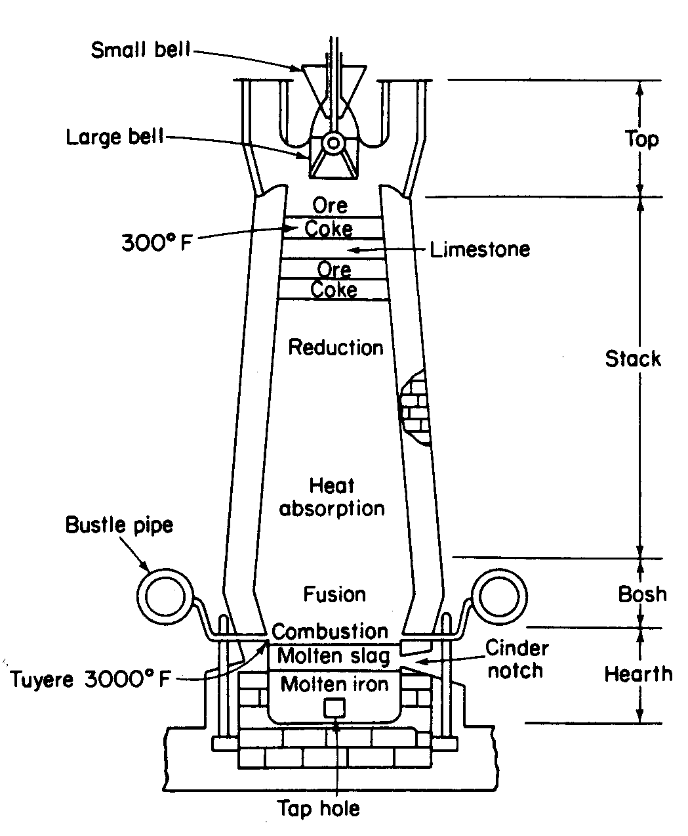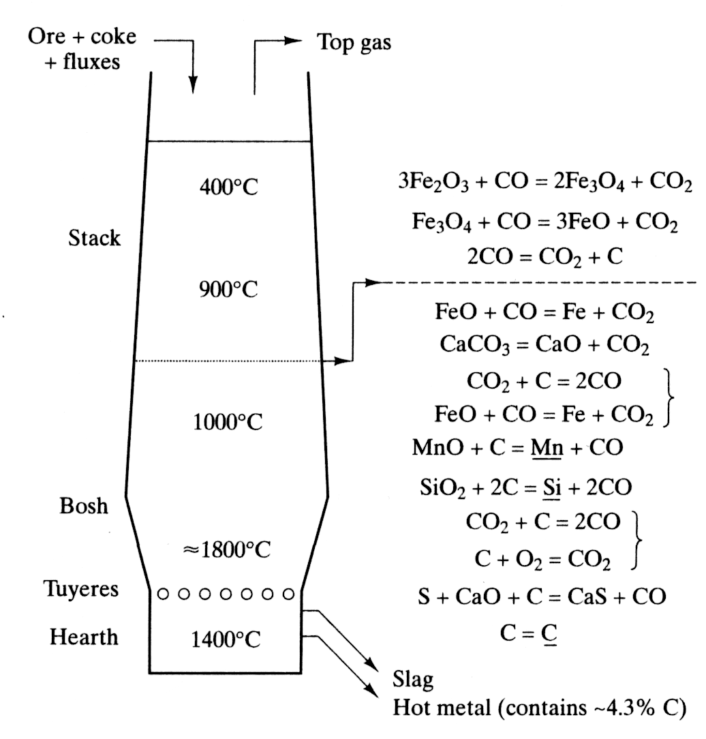
Fig. 2. Sectional views of a blast furnace showing parts, raw materials, reactions, temperature zones, slag and hot metal.

The blast furnace process
1. Conveyors (skip cars) deliver the charge to the top of the furnace.
2. Hot air is then blown through pipes called tuyeres to fire the mixture.
3. The coke burns to increase the temperature in the furnace.
4. The limestone attracts the impurities in the iron ore and forms slag. This slag is lighter than the molten iron and therefore floats on top of it.
5. When the furnace fills, the molten iron is tapped off. The slag is also tapped off at regular intervals. Most iron is taken straight from the blast furnace to the steel mill, but some is poured into buckets called pigs. Hence, pig iron.

Note: The reducing agent may be charcoal, anthracite coal, or coke. Charcoal is the best agent, but it is quite expensive. Limestone or dolomite is used as a flux to enhance slag formation. Slag consists primarily of silicates, aluminosilicates, and calcium-alumina-silicates. The molten slag absorbs much of the sulfur from the charge and comprises about 20% by mass of iron production.

Pig iron is used to make wrought iron, steel and cast iron. It is not ductile or malleable. It is hard and brittle, thereby making it useless for engineering products. Further, it cannot be readily welded.

Chemical composition of pig iron (estimate)
Material | Wt. %Fe (General) | Wt. % Carbon
Pig iron | 90 | 2-6
Steel | 99 | 0.1-2
Wrought iron | 99.7 | Fraction
Wrought Iron:
It is the purest iron commercially available and contains at least 99.5% iron (but may contain up to 99.9% iron). The typical composition of a wrought iron is
C = 0.02% S = 0.108% Slag = 0.07% Si = 0.12% P = 0.02%

Mechanical Properties: Wrought iron is a tough, malleable and ductile material. It can be easily forged or welded. However, it cannot stand sudden and excessive shocks.

Applications: chains, crane hooks, railway couplings, water and steam pipes.

Mechanical properties of wrought iron: Tensile strength = 341MPa; yield strength = 232 MPa); % elongation = 28; % reduction in area = 48.

2. Direct Reduction Process of Iron Production
In the direct reduction process, iron oxide pellets and/or lumps of iron ore are reduced by a reducing gas, producing direct reduced iron (DRI), which is also called sponge iron.

Fig. 3. Sponge Iron (Courtesy of Midrex Direct Reduction Corporation)

Common Steelmaking Methods
The three main steel making methods are: Bessemer converter (somewhat outdated), basic oxygen furnace (BOF), and electric arc furnace (EAF).

The Bessemer Process (presented in the class video)

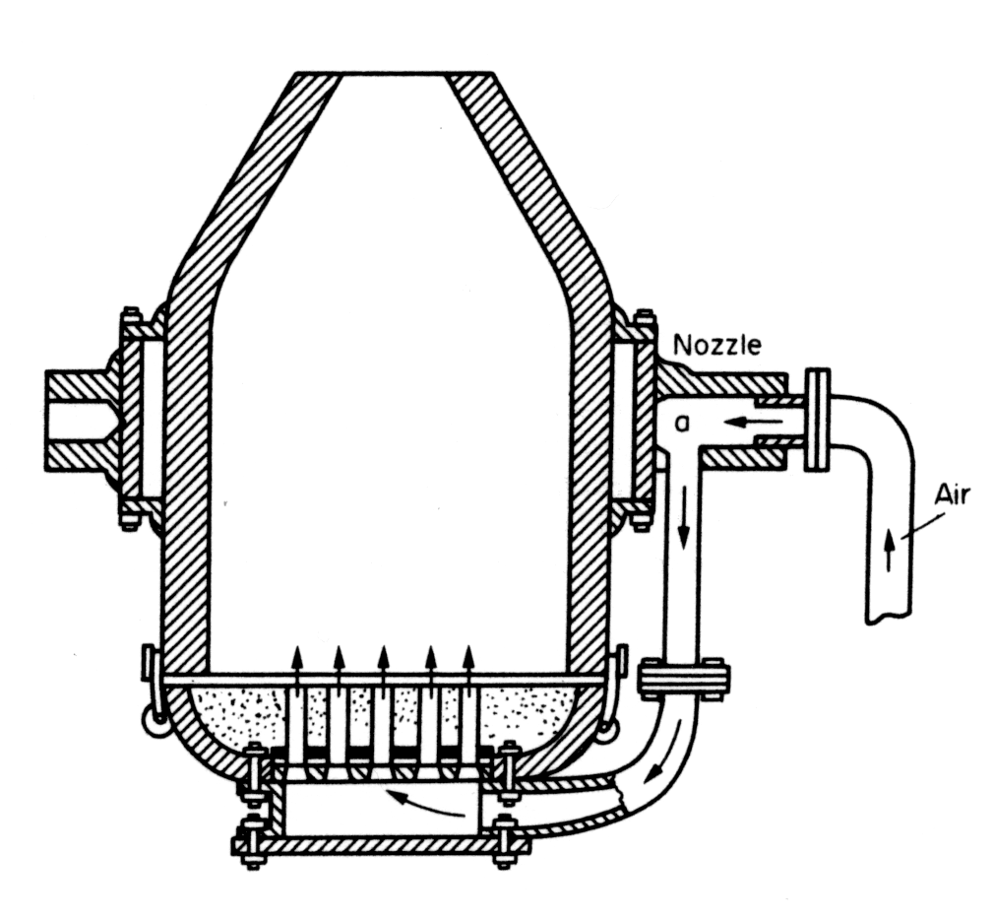

Fig. 4. Schematic of Bessemer steelmaking process.
Basic Oxygen Furnace (BOF)
Like the Bessemer process, the basic oxygen steelmaking process converts the molten iron from the blast furnace (with up to 30% steel scrap) into refined steel. First, the furnace is tilted and charged with scrap. Then hot metal from blast furnace is poured from a ladle into the top of the tilted furnace. The charged furnace is now returned into an upright position. A water-cooled oxygen lance is lowered and high purity oxygen is blown through the molten bath to lower carbon, silicon, manganese, and phosphorous content of the iron, while various fluxes are used to reduce the sulfur and phosphorous levels.
Fig. 5. Schematic of basic oxygen steelmaking process.

Electric Arc Furnace (EAF)
The main application of electric arc furnaces (EAFs) is for the remelting of steel scrap. They can also be charged with limited amounts of iron scrap, pig iron, and direct reduced iron. The furnace is first charged with sorted steel scrap. Then, the graphite electrodes are lowered just above the scrap and an arc is struck. The arc provides the heat (mostly radiative heat) for melting the scrap.

In Saskatchewan, the IPSCO steel plant in Regina uses EAFs to high quality produce steel.

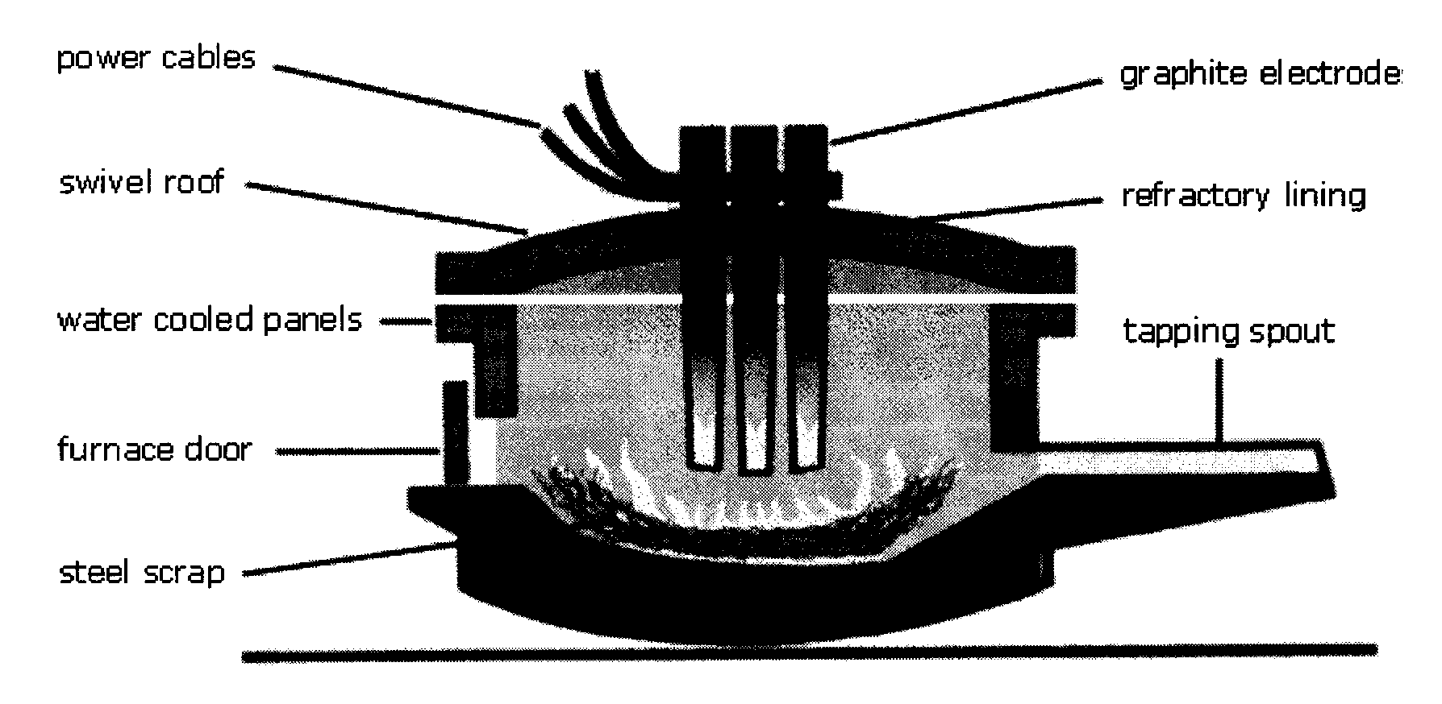

Fig. 6. Schematic of steelmaking process using an electric arc furnace.

Integrated Steelmaking Plant
Visit http://www.steel.org/Content/NavigationMenu/LearningCenter/Learning_Center.htm
for a very cool animation.

