GEOTECHNICAL ENGINEERING IN RESIDUAL SOILS
University of Chile, Santiago

PART 2: FACTORS CONTROLLING THE PROPERTIES AND BEHAVIOUR OF SOILS
(THREE MAIN SOIL GROUPS)

2.1 General Comments.

Soils can be divided into different categories based on various criteria. They can for example be divided into undisturbed and remoulded soils, or they can be divided into normally consolidated soils and over-consolidated soils. They can also be divided into fully saturated and partially saturated soils. These are all valid criteria and serve varying purposes. This course is primarily concerned with residual soils, and hence a division into residual soils and sedimentary soils will be useful. However, it is useful also to include a third division, namely “disturbed” or remoulded soils. This is a useful division as the understanding of undisturbed soil behaviour is generally enhanced if we also know how it behaves when remoulded, and part of this course will consider compaction of residual soils, which by their nature are essentially remoulded soils. Hence the three groups which will be referred to in this course will be sedimentary soils, residual soils, and remoulded soils. Unless otherwise stated the terms sedimentary and residual will refer to the soil in its undisturbed state.

Figure 2.1.1 below illustrates the factors involved in the formation of residual and sedimentary soils, and which ultimately determine the properties and behaviour of the soil.

Sedimentary soils are seen to undergo various additional processes beyond the initial physical and chemical weathering of the parent rock. It might appear from this diagram that the factors involved in the formation of sedimentary soils are more complex than those involved in forming residual soils. There is some truth in this, but in practice two important factors lead to a degree of homogeneity and predictability with sedimentary soils that is absent from residual soils. These factors are

- The sorting process which take place during erosion, transportation and deposition of sedimentary soils tend to produce homogeneous deposits.

- Stress history is a prominent factor in determining the behavioural characteristics of sedimentary soils, and leads to the convenient division of these soils into normally and over consolidated materials.
Figure 2.1.1 Factors influencing soil formation
The absence of these factors with residual soils means that they are generally more complex and less capable of being divided into tidy categories or groups.

Figure 2.1.2 is an attempt to emphasise the principle factors that control the behaviour of undisturbed residual and sedimentary soils, and remoulded soils.

Figure 2.1.2 Principle factors governing properties of residua, sedimentary, and remoulded soils.

The major difference between the two undisturbed groups is the absence of stress history as a factor influencing the behaviour of residual soils. This is often overlooked by geotechnical engineers, who apply concepts developed from the influence of stress history on sedimentary soils to residual soils with misleading results. The important point to remember is that soil properties can be linked closely to their composition and the processes that form them, and to be aware of which of these processes is applicable to any particular soil.

Comments on each of these soil categories are as follows:

2.2. Sedimentary Soils

These soils are well covered in most soil mechanics textbooks and university courses. However, there are developments in the understanding of the behaviour of these soils that may well not be described in text books. One of the most important is that stress history has probably been overstated as a factor governing soil behaviour, and that there are other processes of equal or greater importance. These processes are termed “aging” or “hardening”, meaning a steady increase in strength with time after the original formation of the soil. Careful investigation of recent normally consolidated clays shows that they usually show a pre-consolidation pressure significantly higher than the overburden pressure. They are thus lightly over-consolidated even though geological evidence shows they have never been subjected to higher stresses than those currently acting on them. An example of this behaviour is shown in Figure 2.3. The soil involved is a soft clay found along the north coast of the Thames estuary near London. It was deposited as the sea rose some ten thousand years ago at the close of the last ice age.

The effective overburden pressure was about 27 kPa; however the shape of the compression curve shows a pre-consolidation pressure of about 55 kPa, ie an over-consolidation ratio of about 2.

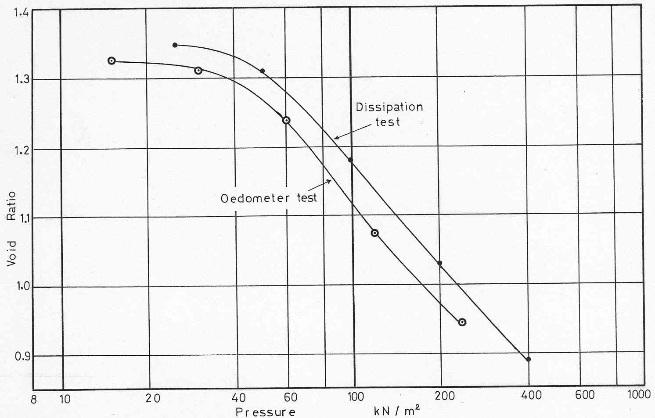

Figure 2.2.1 Oedometer tests on a soft “normally consolidated” clay (Thames estuary)

This over-consolidation effect is believed to be due to a slow “aging” process which involves the development of weak bonds between the clay particles. Thus even with sedimentary soils there are important properties which cannot be attributed to stress history alone.

2.3 Residual Soils

Residual soils are the product of weathering processes on their parent material, which is normally rock. Because of the wide variety of parent material, together with a wide variety of weathering environments, the range of soil types that come within this residual soil group is very large and diverse. While many residual soils contain the same clay minerals as sedimentary soils, there are some residual soils that contain clay minerals not found in sedimentary clays. These are soils derived from the weathering of volcanic soils and the clay minerals concerned are halloysite and allophane. These clay minerals have unusual (even extraordinary) properties and soils containing a high proportion of these minerals may behave in ways that are not found at all in sedimentary soils.

In addition to the influence of unusual clay minerals, residual soils tend also to be strongly influenced by the structure imparted to them by their parent material and the action of the weathering process. Generally this structure has the form of bonds or “cementation” between the particles which existed in the parent rock before the onset of weathering. The effect of continued weathering is normally to weaken these bonds so that the strength of the soil will very slowly decrease with time. However there are situations where the weathering process may involve the opposite effect. Weathering of loose volcanic material often results in the development of bonds that become stronger with time.
The most significant properties of residual soils can be summarised as follows:

(a) Variability and heterogenuity

(b) Structure – (a) from features of parent rock (b) new, from weathering process.

(c) The soil may not be “particulate” ie not a collection of individual particles, more in the nature of a “soil skeleton” or “frame”.

(d) Absence of stress history influence

(e) Presence of unusual clay minerals

(f) The zone of interest to geotechnical engineers may be mainly above the water table.

2.4 Remoulded Soils

This category includes soils prepared by sedimentation from an artificially prepared slurry, as well as compacted. The term “de-structured” is frequently use these days to designate such soils. The properties of these soils are thus not governed by any form of structure, as likely to be the case with most undisturbed soils. Compacted clays may be an exception to this statement to a small extent, as it is possible that the compaction process does create some form of structure in the compacted material.

