**Exponentiation**

X raised to the power of Y = X ^ Y

**E raised to an x power**

**E** is a mathematical constant that is approximately equal to 2.7. It is an irrational number, but if truncated to 20 decimals, it would be 2.7182818284590452353.

Revit usage = exp(x)

**Circles with pi π**

Usage in Revit = pi()

Circumference = pi() * (Radius * 2)

Circumference = pi() * Diameter

Circle Area = pi() * Radius ^ 2

Arch Length = (Degree / 360) * 2 * pi() * Radius

**Square Root**

Fixed value = sqrt(999)

Parameter = sqrt(Width)

Formula= sqrt(Width + Height)

**Logarithm**

The logarithm of a number to a given base is the exponent to which the base must be raised in order to produce that number. For example, the logarithm of 1000 to base 10 is 3, because three factors of 10 must be multiplied to yield a thousand: 10 × 10 × 10 equals 1000 Revit usage = log(1000)

**Force yes/no parameters to be checked or unchecked**

Force checked = 1 < 2

Force unchecked = 1 > 2

**Conditional statements**

Conditional statement uses this structure:

IF (<condition>, <result-if-true>, <result-if-false>)

**Supported Conditional Operators**

**<** *Less than*

**>** *Greater than*

**=** *Equal*

**/** *Divide*

**AND** *Both statements are true*

**OR** *One of the statements is true*

**NOT** *Statement is false*

Conditional statements can contain numeric values, numeric parameter names, and **Yes/No** parameters.

Currently, **<=** and **>=** are not implemented. To express such a comparison, you can use a logical **NOT**. For example, a<=b can be entered as NOT(a>b)

**Simple IF Statement**

*IF (Length < 900, <true>, <false>)*

**Formula That Returns Strings**

*IF (Length < 900, “Opening too narrow”, “Opening OK”)*

**Using logical AND**

*IF ( AND (x = 1 , y = 2), <true>, <false>)*

Returns <true> if both x=1 and y=2, else <false>

**Using logical OR**

*IF ( OR ( x = 1 , y = 2 ) , <true>, <false>)*

Returns <true> if either x=1 or y=2, else <false>

**Nested IF statements**

*IF ( Length < 500 , 100 , IF ( Length < 750 , 200 , IF ( Length < 1000 , 300 , 400 ) ) )*

Returns 100 if Length<500, 200 if Length<750, 300 if Length<1000 and 400 if Length>1000

**IF with Yes/No condition**

*Length > 40*

Returns checked box (<true>) if Lenght > 40

**NOT with Yes/No condition**

*not(Viz)*

Returns checked box (<true>) if Yes/No parameter "Viz" is unchecked, and returns unchecked box (<false>) if Yes/No parameter "Viz" is checked.

**IF AND OR Returning the greatest of three values**

Say you have these 3 length parameters, and want a fourth parameter to return the greater value/length of the 3:

**Length A**

**Length B**

**Length C**

Return Length (Returns the greatest of the three length parameters) Return Length = if(and(or(Length A > Length B, Length A = Length B), or(Length A > Length C, Length A = Length C)), Length A, if(and(or(Length B > Length A, Length B = Length A), or(Length B > Length C, Length B = Length C)), Length B, if(and(or(Length C > Length A, Length C = Length A), or(Length C > Length B, Length C = Length B)), Length C, 0 mm)))

**Credit to: Joe Zhou for this formula!**

Another option is to use an extra "Calc" parameter, which is a bit more clumsy but also way easier and more manageable for us mortals.

*Calc = if(Length A > Length B, Length A, Length B)*

Return Length = if(Calc > Length C, Calc, Length C)

And a third option:

Return Length = if(A > D, if(A > C, if(A > B, A, B), if(B > C, B, C)), if(B > D, if(B > C, B, C), if(C > D, C, D)))

**Credit to: Ekkonap who**[**posted**](http://www.revitforum.org/tutorials-tips-tricks/1046-revit-formulas-everyday-usage-4.html#post17873)**this on May 23rd 2011.**

**Trigonometry for right triangles:**

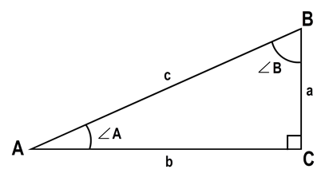

**Known: a+b**

c = sqrt(a ^ 2 + b ^ 2) A = atan(a / b) B = atan(b / a)

**Known: a+c**

b = sqrt(c ^ 2 - a ^ 2) A = asin(a / c) B = acos(a / c)

**Known: b+c**

a = sqrt(c ^ 2 - b ^ 2) A = acos(b / c) B = asin(b / c)

**Known: c + A**

a = c * sin(A) b = c * cos(A) B = 90° - A

**Known: c + B**

a = c * cos(B) b = c * sin(B) A = 90° - B

**Known: a + B**

b = a * tan(B) c = a / cos(B) A = 90° - B

**Known: b + A**

a = b * tan(A) c = b / cos(A) B = 90° - A

**Known: a + A**

b = a / tan(A) c = a / sin(A) B = 90° - A

**Known: b + B**

a = b / tan(B) c = b / sin(B) A = 90° - B

**Range of Values**

Given the following parameters:

**user_value:**

**min_value:**

**max_value:**

actual_value: = if (user_value < min_value, min_value, if (user_value > max_value, max_value, user_value))

Specify a range of valid entries, with the min_value and max_value parameters; then, use the actual value if it is within the range; otherwise, use your minimum or maximum values.

**Credits: Alfredo Medina, who**[**posted**](http://www.revitforum.org/tutorials-tips-tricks/1046-revit-formulas-everyday-usage-2.html#post10363)**this on March 23rd 2011**

**Circular Segments**

To calculate the Segment length, the Chord Length, the Angle etc.

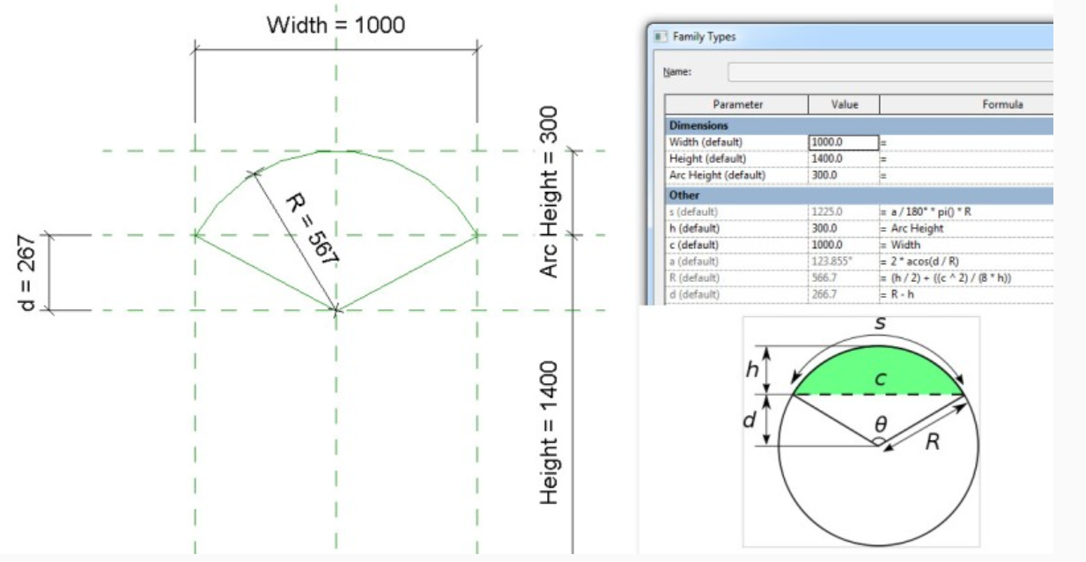

Sample file posted [here](http://www.revitforum.org/tutorials-tips-tricks/1046-revit-formulas-everyday-usage-11.html#post35048)

**Inconsistent Units**

There's a separate post explaining this behavior here: [Revit - Inconsistent Units and how to neutralize them.](http://revitforum.org/tutorials-tips-tricks/1138-revit-inconsistent-units-how-neutralize-them.html)

**Round Function In Formulas**

Values in formulas can be now rounded up or down. For example, when riser height is calculated, one needs the function “round” to find the appropriate value.

**ROUND(x)**

The **round** function returns a number rounded nearest to a whole number. It doesn’t take into consideration rounding direction (round up or down). If the number is (for example) from 24.5 to 24.9, the function rounds it to 25. If it is from 23.1 to 23.4, the function rounds it to 23.

Examples:

round ( 23.4) = 23

Round ( 23.5) = 24

Round ( 23.6) = 24

Round (-23.4) = -23

Round (-23.5) = -23

Round (-23.6) = -24

**Syntax**

The syntax for the **round** function is: round( number)

number is the number to round.

**ROUNDDOWN(x)**

“x” is a unitless value that should return the smallest integral value less than or equal to x.

For example:

rounddown ( 23.0) = 23

rounddown ( 23.5) = 23

rounddown ( 23.9) = 23

rounddown (-23.0) = -23

rounddown (-23.5) = -24

rounddown (-23.9) = -24

**Syntax**

The syntax for the **rounddown** function is: **rounddown** (number)

number is the number to round down.

**ROUNDUP(x)**

“x” is a unitless value that should return the largest integral value greater than or equal to x.

For example:

roundup ( 23.0) = 23

roundup ( 23.5) = 24

roundup ( 23.9) = 24

roundup (-23.0) = -23

roundup (-23.5) = -23

roundup (-23.9) = -23

**Syntax**

The syntax for the **roundup** function is: **roundup** (number)  number is the number to round up.  Note that when numbers such as 23.5 are rounded, they can result in either 23 or 24. To produce a stable result, for all the .5 cases, we round to the larger integer. That means that 23.5 is rounded to 24, while -23.5 to -23

**Round to a number:**

number to round: X

number to round to: Y

(ROUND(X/Y))*Y

rounding a parameter value to the nearest five would look like this:

(ROUND(<parameter>/5))*5

**Credit to: Sander_Malschaert**