**Advalanche: Amazon reports earnings**

Today the e-commerce giant will announce its results. While selling goods remains its core enterprise, shareholders will be looking for clues about a small but growing business line: advertising. With 4.1% of the American market, Amazon is still much smaller than Google and Facebook, but its nascent business is growing more swiftly. In 2018 Amazon could claim $8bn in ad sales worldwide, contributing perhaps $3bn in operating profit—around 27% of total profits for the year. By 2021, it is “highly likely” that profits from Amazon’s advertising business could exceed those from its lucrative cloud computing unit, Amazon Web Services (AWS), according to Michael Olson of Piper Jaffray, a brokerage firm. This could lead to a formidable strategic advantage. While Amazon loses money on its core e-commerce business, advertising carries fat profits, which the company can leverage to push into new business lines and new countries. The giant looks likely to get bigger.

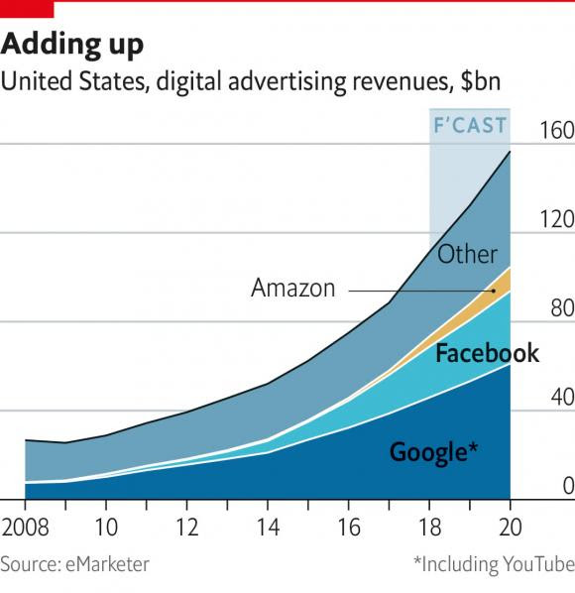

Fuente: The Economist Espresso, 25/10/18.