Control 01 ECUACIONES DIFERENCIALES

Parte 1 (70%)

Resolver las siguientes ecuaciones diferenciales de primer orden con condiciones iniciales.
- La ecuación se debe colocar en su forma canónica
- Se debe determinar la solución homogénea de forma analítica
- Se debe determinar la solución particular de forma analítica
- Se debe a partir de la condición inicial las constantes de forma analítica si corresponde

Ecuación Diferencial 1.1 (10pts)

$$sin(t)\frac{dy}{dt}+cos(t)y=\sin^{3}(t)$$
$$\begin{matrix}y(π/2) = -1 & & t_{0}=π/2\end{matrix}$$

Ecuación Diferencial 1.2 (10pts)

$$\frac{dy}{dt}+4πy=\frac{4}{π}\sum_{n=1}^{∞}{\frac{1}{2n-1}}sin\left[\left(2n-1\right)t\right]$$
$$\begin{matrix}y(0) = 4 & & t_{0}=0\end{matrix}$$

Ecuación Diferencial 1.3 (10pts)

$$\frac{d^{3}y}{dt^{2}}+3\frac{d^{2}y}{dt^{2}}+7\frac{dy}{dt}+5y =e^{-2t}$$
$$\begin{matrix}y(0) = 1 & & t_{0}=0\end{matrix}$$
$$\begin{matrix}y'(0) = 0 & & t_{0}=0\end{matrix}$$
$$\begin{matrix}y''(0) = 0 & & t_{0}=0\end{matrix}$$

Ecuación Diferencial 1.4 (10pts)

$$\frac{d^{2}y}{dt^{2}}+2\frac{dy}{dt}+37y =0$$
$$\begin{matrix}y(0) = 1 & & t_{0}=0\end{matrix}$$
$$\begin{matrix}y'(0) = 1 & & t_{0}=0\end{matrix}$$

Parte 2 (15%)

Serie de Fourier 2.1 (10pts)

Resolver la Series de Fourier Compleja de forma analítica escribir el procedimiento y graficar con un programa de Octave/MATLAB

$$f\left(t\right)=\begin{matrix}t^{4}-1 & -1≤t≤1\end{matrix}$$

Serie de Fourier 2.2 (10pts)

Graficar el Resultado de la solución para $y\left(t\right)$ dada por la ecuación con un programa de Octave/MATLAB

$$\frac{dy}{dt}+4πy=\frac{4}{π}\sum_{n=1}^{∞}{\frac{1}{2n-1}}sin\left[\left(2n-1\right)t\right]$$
$$\begin{matrix}y(0) = 4 & & t_{0}=0\end{matrix}$$

Parte 3 (15%)

Ecuación Diferencial 3.1 (10pts)

Resuelva usando diferencias centrales y grafique los resultados incluyendo, desplazamiento, velocidad y diagrama de fase

$$M\frac{d^{2}X}{dt^{2}}+C\frac{dX}{dt}+KX=f\left(t\right)$$

%matriz de masa
M = [1, 1, 0, 0, 0;
1, 2, 1, 0, 0;
0, 1, 3, 1, 0;
0, 0, 1, 2, 1;
0, 0, 0, 1, 1];

%matriz de rigidez
K = [ 400,-200, 0, 0, 0;
-200, 400,-200, 0, 0;
0,-200, 400,-200, 0;
0, 0,-200, 400,-200;
0, 0, 0,-200, 200];

%matriz de amortiguamiento
C = [20, -10, 0, 0, 0;
-10, 20, -10, 0, 0;
0, -10, 20, -10, 0;
0, 0, -10, 20, -10;
0, 0, 0, -10, 10];

%% condiciones iniciales

x0 = [0;0;0;0;0]; %desplazamiento inicial
v0 = [0;0;0;0;0]; %velocidad inicial

%componentes
f1(1:N) = 0; %inicialización de fuerza
f2(1:N) = 0; %inicialización de fuerza
f3(1:N) = 0; %inicialización de fuerza
f4(1:N) = 0; %inicialización de fuerza
f5(1:N) = 0; %inicialización de fuerza

tf1 = 10; %tiempo1
tf2 = 50; %tiempo2
tf3 = 90; %tiempo2
nf1 = round(tf1/dt); %muestra1
nf2 = round(tf2/dt); %muestra2
nf3 = round(tf3/dt); %muestra2

f1(nf1:nf2) = 50;
f1(nf2+1:nf3) = -50;

Ecuación Diferencial 3.2 (10pts)

Resuelva la ecuación diferencial ordinaria de segundo orden no lineal, con valores iniciales mediante el método de Euler, incluyendo, desplazamiento, velocidad, diagrama de fase y espacio de fase

$$y'' + δy' + βy^{3} + ω_{0}y =γcos(ωt + φ_{0})$$

$$y\left(0\right)=0.5$$
$$y^{'}\left(0\right)=-0.5$$

%datos
$δ$ delta = 1.0;
$β$ beta = 1.0;
$ω_{0}$ w0 = -1.0;
$γ$ gama = 1.0;
$φ_{0}$ phi0 = 0.0;
$ω$ w = 0.1;

%tiempo incial/final
tini = 0;
tfin = 200;

Ecuación Diferencial 1.1 (10pts)

$$sin(t)\frac{dy}{dt}+cos(t)y=\sin^{3}(t)$$
$$\begin{matrix}y(π/2) = -1 & & t_{0}=π/2\end{matrix}$$

Ecuación Homogénea – Solución Complementaria

$$sin(t)\frac{dy_{c}}{dt}+cos(t)y_{c}=0$$

$$sin\left(t\right)\frac{dy_{c}}{dt}=-cos(t)y_{c}$$

$$\frac{dy_{c}}{y_{c}}=-\frac{cos(t)}{sin\left(t\right)}dt$$

$$\int{\frac{dy_{c}}{y_{c}}}=-\int{\frac{cos(t)}{sin\left(t\right)}dt}$$

$$ln\left|y_{c}\right|=-ln\left|sin\left(t\right)\right|+C$$

$$ln\left|y_{c}\right|=ln\left|\frac{1}{sin\left(t\right)}\right|+C$$

$$y_{c}\left(t\right)=\frac{C}{sin\left(t\right)}$$

Solución Particular

$$y_{p}=u(t)y_{1}(t)$$

$$y_{1}\left(t\right)=\frac{1}{sin\left(t\right)}$$

$$u(t)=\int{\frac{f(t)}{y_{1}(t)} dt}$$

$$u(t)=\int{\frac{\sin^{2}(t)}{\frac{1}{sin\left(t\right)}} dt}$$

$$u(t)=\int{\sin^{3}(t) dt}$$

$$u(t)= \frac{1}{12}\left[cos\left(3t\right)-9cos\left(t\right)\right]$$

$$y_{p}(t)=u\left(t\right)y_{1}\left(t\right)=\frac{1}{12}\left[\frac{cos\left(3t\right)-9cos\left(t\right)}{sin\left(t\right)}\right]$$

Solución Completa

$$y\left(t\right)=y_{c}\left(t\right)+y_{p}(t)$$

$$y\left(t\right)=\frac{C}{sin\left(t\right)}+\frac{1}{12}\left[\frac{cos\left(3t\right)-9cos\left(t\right)}{sin\left(t\right)}\right]$$

Condición Inicial

$$y\left(π/2\right)=-1$$

$$y\left(π/2\right)=\frac{C}{sin\left(π/2\right)}+\frac{1}{12}\left[\frac{cos\left(3×π/2\right)-9cos\left(×π/2\right)}{sin\left(π/2\right)}\right]=-1$$

$$y\left(π/2\right)=\frac{C}{1}+\frac{1}{12}\left[\frac{ 0-0}{1}\right]=-1$$

$$y\left(π/2\right)=C+0=-1$$

$$C=-1$$

Finalmente

$$y\left(t\right)=\frac{-1}{sin\left(t\right)}+\frac{1}{12}\left[\frac{cos\left(3t\right)-9cos\left(t\right)}{sin\left(t\right)}\right]$$

Ecuación Diferencial 1.2 (10pts)

$$\frac{dy}{dt}+4πy=\frac{4}{π}\sum_{n=1}^{∞}{\frac{1}{2n-1}}sin\left[\left(2n-1\right)t\right]$$
$$\begin{matrix}y(0) = 4 & & t_{0}=0\end{matrix}$$

Ecuación Homogénea – Solución Complementaria

$$\frac{dy_{c}}{dt}+4πy_{c}=0$$

$$\frac{dy_{c}}{y_{c}}=-4π dt=0$$

$$\int{\frac{dy_{c}}{y_{c}}}=-\int{4π dt}=0$$

$$ln\left|y_{c}\right|=-4πt+C$$

$$y_{c}\left(t\right)=Ce^{-4πt}$$

Solución Particular

$$y_{p}\left(t\right)=u(t)y_{1}\left(t\right)$$

$$y_{1}\left(t\right)=e^{-4πt}$$

$$u(t)=\int{\frac{f(t)}{y_{1}\left(t\right)} dt}$$

$$u(t)=\int{\frac{\sum_{n=1}^{∞}{\frac{4}{π}\frac{1}{2n-1}sin\left[\left(2n-1\right)t\right]}}{e^{-4πt}} dt}$$

En nuestro caso podemos aislar un término genérico e intercambiar la integral por la sumatoria

$$u_{n}(t)=\int{\frac{\frac{4}{π}\frac{1}{2n-1}sin\left[\left(2n-1\right)t\right]}{e^{-4πt}} dt}$$

$$u_{n}(t)=\int{\frac{4}{π}\frac{1}{2n-1}sin\left[\left(2n-1\right)t\right]e^{4πt} dt}$$

$$u_{n}\left(t\right)=\frac{4}{π\left(2n-1\right)}\left\{\frac{4πsin\left[\left(2n-1\right)t\right]+\left(1-2n\right)cos\left[\left(1-2n\right)t\right]}{\left(4n^{2}-4n+16π^{2}+1\right)}\right\}e^{4πt}$$

$$y_{pn}\left(t\right)=u_{n}(t)y_{1}\left(t\right)$$

$$y_{pn}\left(t\right)=e^{-4πt}\frac{4}{π\left(2n-1\right)}\left\{\frac{4πsin\left[\left(2n-1\right)t\right]+\left(1-2n\right)cos\left[\left(1-2n\right)t\right]}{\left(4n^{2}-4n+16π^{2}+1\right)}\right\}e^{4πt}$$

$$y_{pn}\left(t\right)=\frac{4}{π\left(2n-1\right)}\left\{\frac{4πsin\left[\left(2n-1\right)t\right]+\left(1-2n\right)cos\left[\left(1-2n\right)t\right]}{\left(4n^{2}-4n+16π^{2}+1\right)}\right\}$$

$$y_{p}\left(t\right)=\sum_{n=1}^{∞}{y_{pn}\left(t\right)}$$

$$y_{p}\left(t\right)=\sum_{n=1}^{∞}{\frac{4}{π\left(2n-1\right)}\left\{\frac{4πsin\left[\left(2n-1\right)t\right]+\left(1-2n\right)cos\left[\left(1-2n\right)t\right]}{\left(4n^{2}-4n+16π^{2}+1\right)}\right\}}$$

Solución completa

$$y\left(t\right)=y_{c}\left(t\right)+y_{p}\left(t\right)$$

$$y\left(t\right)=Ce^{-4πt}+\sum_{n=1}^{∞}{\frac{4}{π\left(2n-1\right)}\left\{\frac{4πsin\left[\left(2n-1\right)t\right]+\left(1-2n\right)cos\left[\left(1-2n\right)t\right]}{\left(4n^{2}-4n+16π^{2}+1\right)}\right\}}$$

Condiciones Iniciales

$$\begin{matrix}y(0) = 4 & & t_{0}=0\end{matrix}$$

$$y\left(0\right)=Ce^{-4π×0}+\sum_{n=1}^{∞}{\frac{4}{π\left(2n-1\right)}\left\{\frac{4πsin\left[\left(2n-1\right)×0\right]+\left(1-2n\right)cos\left[\left(1-2n\right)×0\right]}{\left(4n^{2}-4n+16π^{2}+1\right)}\right\}}=4$$

$$y\left(0\right)=C+\sum_{n=1}^{∞}{\frac{4}{π\left(2n-1\right)}\left\{\frac{\left(1-2n\right)}{\left(4n^{2}-4n+16π^{2}+1\right)}\right\}}=4$$

$$y\left(0\right)=C-\sum_{n=1}^{∞}{\frac{4}{π\left(4n^{2}-4n+16π^{2}+1\right)}}=4$$

$$C=4+4\sum_{n=1}^{∞}{\frac{1}{π\left(4n^{2}-4n+16π^{2}+1\right)}}$$

$$C=4.172964$$

Solución

$$y\left(t\right)=4.172964e^{-4πt}+\sum_{n=1}^{∞}{\frac{4}{π\left(2n-1\right)}\left\{\frac{4πsin\left[\left(2n-1\right)t\right]+\left(1-2n\right)cos\left[\left(1-2n\right)t\right]}{\left(4n^{2}-4n+16π^{2}+1\right)}\right\}}$$

Ecuación Diferencial 1.3 (10pts)

$$\frac{d^{3}y}{dt^{2}}+3\frac{d^{2}y}{dt^{2}}+7\frac{dy}{dt}+5y =e^{-2t}$$
$$\begin{matrix}y(0) = 1 & & t_{0}=0\end{matrix}$$
$$\begin{matrix}y'(0) = 0 & & t_{0}=0\end{matrix}$$
$$\begin{matrix}y''(0) = 0 & & t_{0}=0\end{matrix}$$

Ecuación Homogénea – Solución Particular

$$\frac{d^{3}y_{c}}{dt^{2}}+3\frac{d^{2}y_{c}}{dt^{2}}+7\frac{dy_{c}}{dt}+5y_{c} =0$$

Polinomio característico

$$s^{3}+3s^{2}+7s+5=0$$

Raíces

$$\begin{matrix}s_{1}=-1 & s_{2}=-1+j2 & s_{3}=-1-j2\end{matrix}$$

$$y_{c}\left(t\right)=C_{1}e^{-t}+e^{-t}\left(C_{2}cos\left(2t\right)+C_{3}sin\left(2t\right)\right)$$

Solución Complementaria – Método de los coeficientes Indeterminados

$$\frac{d^{3}y_{p}}{dt^{2}}+3\frac{d^{2}y_{p}}{dt^{2}}+7\frac{dy_{p}}{dt}+5y_{p} =e^{-2t}$$

$$y_{p}\left(t\right)=Ae^{-2t}$$

Derivamos

$${y'}_{p}\left(t\right)=-2Ae^{-2t}$$
$${y''}_{p}\left(t\right)=4Ae^{-2t}$$
$${y'''}_{p}\left(t\right)=-8Ae^{-2t}$$

Reemplazamos

$$\left(-8+12-14+5\right)Ae^{-2t} =e^{-2t}$$

$$-5Ae^{-2t} =e^{-2t}$$

$$A=-\frac{1}{5}$$

$$y_{p}\left(t\right)=-\frac{1}{5}e^{-2t}$$

Solución Completa

$$y\left(t\right)=y_{c}\left(t\right)+y_{p}\left(t\right)$$

$$y\left(t\right)=C_{1}e^{-t}+e^{-t}\left(C_{2}cos\left(2t\right)+C_{3}sin\left(2t\right)\right)-\frac{1}{5}e^{-2t}$$

Derivadas

$$\frac{dy\left(t\right)}{dt}=-C_{1}e^{-t}+ e^{-t}\left(2C_{3}cos\left(2t\right)-2C_{2}sen\left(2t\right)\right)- e^{-t}\left(C_{2}cos\left(2t\right)+C_{3}sen\left(2t\right)\right)+ \frac{2}{5}e^{-2 t}$$

$$\frac{d^{2}y\left(t\right)}{dt^{2}}=C_{1}e^{-t}- 2e^{-t}\left(2C_{3}cos\left(2t\right)- 2C_{2} sen\left(2t\right)\right)+ e^{-t}\left(-4C_{2}cos\left(2t\right)- 4C_{3}sen\left(2t\right)\right)+ e^{-t}\left(C_{2}cos\left(2t\right)+ C_{3}sen\left(2t\right)\right)-\frac{4 e^{-2 t}}{5}$$

Condiciones Iniciales

$$y\left(0\right)=C_{1}e^{-0}+e^{-0}\left(C_{2}cos\left(2×0\right)+C_{3}sin\left(2×0\right)\right)-\frac{1}{5}e^{-2×0} = 1$$
$$y'\left(0\right)=-C_{1}e^{-0}+ e^{-0}\left(2C_{3}cos\left(2×0\right)-2C_{2}sen\left(2×0\right)\right)- e^{-t}\left(C_{2}cos\left(2×0\right)+C_{3}sen\left(2×0\right)\right)+ \frac{2}{5}e^{-2 ×0}=0$$
$$y''\left(0\right)=C_{1}e^{-0}- 2e^{-0}\left(2C_{3}cos\left(2×0\right)- 2C_{2} sen\left(2×0\right)\right)+ e^{-0}\left(-4C_{2}cos\left(2×0\right)- 4C_{3}sen\left(2×0\right)\right)+ e^{-0}\left(C_{2}cos\left(2×0\right)+ C_{3}sen\left(2×0\right)\right)-\frac{4 e^{-2×0}}{5}=0$$
Ordenamos

$$y\left(0\right)=C_{1}+C_{2}-\frac{1}{5} = 1$$
$$\frac{dy\left(0\right)}{dt}=-C_{1}-C_{2}+2C_{3} + \frac{2}{5}=0$$
$$\frac{d^{2}y\left(0\right)}{dt^{2}}=C_{1}-3C_{2}-4C_{3} -\frac{4 }{5}=0$$

Sistema de Ecuaciones

$$C_{1}+C_{2} = \frac{6}{5}$$
$$-C_{1}-C_{2}+2C_{3} =-\frac{2}{5}$$
$$C_{1}-3C_{2}-4C_{3}=\frac{4}{5}$$

$$\begin{matrix}C_{1}=\frac{3}{2} & C_{2}=-\frac{3}{10} & C_{3}=\frac{2}{5}\end{matrix}$$

Finalmente

$$y\left(t\right)=\frac{3}{2}e^{-t}+e^{-t}\left(-\frac{3}{10}cos\left(2t\right)+\frac{2}{5}sin\left(2t\right)\right)-\frac{1}{5}e^{-2t}$$

Ecuación Diferencial 1.4 (10pts)

$$\frac{d^{2}y}{dt^{2}}+2\frac{dy}{dt}+37y =0$$
$$\begin{matrix}y(0) = 1 & & t_{0}=0\end{matrix}$$
$$\begin{matrix}y'(0) = 1 & & t_{0}=0\end{matrix}$$

Ecuación Homogénea – Solución Complementaria

$$\frac{d^{2}y_{c}}{dt^{2}}+2\frac{dy_{c}}{dt}+37y_{c} =0$$

Polinomio característico

$$s^{2}+2s+37=0$$

Raíces

$$s_{1,2}=-1±j6$$

Solución Complementaria

$$y_{c}\left(t\right)=e^{-t}\left(C_{1}cos\left(6t\right)+C_{2}cos\left(6t\right)\right)$$
$$\frac{dy_{c}\left(t\right)}{dt}= -e^{-t}\left(C_{1}cos\left(6t\right)+C_{2}sin\left(6t\right)\right)+e^{-t}6\left(-C_{1}sin\left(6t\right)+C_{2}cos\left(6t\right)\right)$$

Solución Particular

$$y_{p}\left(t\right)=0$$

Condiciones Iniciales

$$y\left(0\right)=e^{-1×0}\left(C_{1}cos\left(6×0\right)+C_{2}cos\left(6×0\right)\right)= 1$$

$$\frac{dy_{c}}{dt}(0)=-e^{-1×0}\left(C_{1}cos\left(6×0\right)+C_{2}sin\left(6×0\right)\right)+e^{-1×0}6\left(C_{1}sin\left(6×0\right)+C_{2}cos\left(6×0\right)\right)=1$$

Sistema de Ecuaciones

$$C_{1}=1$$
$$-C_{1}+6C_{2}=1$$

$$\begin{matrix}C_{1}=1 & C_{2}=\frac{1}{3}\end{matrix}$$

$$y\left(t\right)=e^{-t}\left(cos\left(6t\right)+\frac{1}{3}cos\left(6t\right)\right)$$

Parte 2 (15%)

Serie de Fourier 2.1 (10pts)

Resolver la Series de Fourier Compleja de forma analítica escribir el procedimiento y graficar con un programa de Octave/MATLAB

$$f\left(t\right)=\begin{matrix}t^{4}-1 & -1≤t≤1\end{matrix}$$

$$T=\begin{matrix}2 & p=1\end{matrix}$$

$$c_{n}=\frac{1}{2p}\int_{-p}^{p}{f\left(t\right)e^{-j\left(\frac{nπ}{p}t\right)} dt}$$

$$c_{n}=\frac{1}{2}\int_{-1}^{1}{\left(t^{4}-1\right)e^{-j\left(nπt\right)} dt}$$

$$c_{n}={\left.\frac{1}{2n^{5}π^{5}}\left\{\left[4n^{3}π^{3}t^{3}-24nπt\right]+j\left[n^{4}π^{4}\left(t^{4}-1\right)-12n^{2}π^{2}t^{2}+24\right]\right\}e^{-j\left(nπt\right)}\right|}_{-1}^{1}$$

$$c_{n}=\frac{4 \left(n π\left(-6 + n^{2}π^{2}\right)\cos\left(n π\right)- 3 \left(-2 + n^{2}π^{2}\right)sen\left(n π\right)\right)}{n^{5}π^{5}}$$

$$c_{n}=\frac{4 }{n^{4}π^{4}}{\left(-1\right)}^{n}\left(n^{2}π^{2}-6 \right)$$

$$f(t)=\sum_{n= -∞}^{∞}{c_{n}e^{jnt}}$$

$$f(t)=\sum_{n= -∞}^{∞}{\frac{4 }{n^{4}π^{4}}{\left(-1\right)}^{n}\left(n^{2}π^{2}-6 \right)e^{jnt}}$$

%% control 01 parte serie de fourier compleja 2.1

%
% f(t) = (t^4 -1) -1 <= t <= 1
%

clearvars;
close all;
clc;

%% definiciones
Tmin = -10;
Tmax = 10;
dt = 0.05;

%%tiempo
t = Tmin:dt:Tmax;
Nt = length(t);

%%función
f2t = zeros(1,Nt);

%% serie de fourier

figure(1)
plot(t,f2t);
title('serie de fourier');
xlabel('t (s)');
ylabel('f(t) (Pa)');
grid on;
box on;

%sumatoria
N = 201;

for n = 1:N
nn(n) = -round(N/2) + n;

%coeficiente

%valor c(n)
if nn(n) ~= 0
cn(n) = (4/(nn(n)^4*pi^4 ))*(-1)^nn(n)*(nn(n)^2*pi^2 - 6 );
else
cn(n) = -8/5;
end

%funcion
f2t = f2t + cn(n)*exp(j*nn(n)*t);

figure(1)
plot(t,f2t);
title('serie de fourier');
xlabel('t (s)');
ylabel('f(t) (Pa)');
legend(['f(t) n = ',num2str(nn(n))]);
axis([Tmin,Tmax,-2,-0.5]);
grid on;
box on;

pause(0.05);

end

%% figura final
figure(2)
plot(t,f2t);
title('serie de fourier');
xlabel('t (s)');
ylabel('f_2(t) (Pa)');
legend(['f_2(t) n = ',num2str(nn(n))]);
axis([Tmin,Tmax,-2,-0.5]);
grid on;
box on;

%% figura final parte real e imaginaria
figure(3)

subplot(2,1,1)
plot(t,real(f2t));
title('parte real f_2(t)');
xlabel('t');
ylabel('real(f_2(t))');
legend('real(f_2(t))');
axis([Tmin,Tmax,-2,-0.5]);
grid on;
box on;

subplot(2,1,2)
plot(t,imag(f2t));
title('parte imaginaria f_2(t)');
xlabel('n');
ylabel('imag(f_2(t))');
legend('imag(f_2(t))');
axis([Tmin,Tmax,1.1*min(imag(f2t)),1.1*max(imag(f2t))]);
grid on;
box on;

%% figura coeficientes
figure(4)

subplot(2,1,1)
stem(nn,real(cn));
title('coeficientes parte realc_n');
xlabel('n');
ylabel('real(c_n)');
legend('real(c_n)');
grid on;
box on;

subplot(2,1,2)
stem(nn,imag(cn));
title('coeficientes parte imaginaria c_n');
xlabel('n');
ylabel('imag(c_n)');
legend('imag(c_n)');
grid on;
box on;

figure(5)

subplot(2,1,1)
stem(nn,abs(cn));
title('amplitud c_n');
xlabel('n');
ylabel('abs(c_n)');
legend('abs(c_n)');
grid on;
box on;

subplot(2,1,2)
stem(nn,angle(cn));
title('fase c_n');
xlabel('n');
ylabel('fase(c_n)');
legend('fase(c_n)');
grid on;
box on;

Serie de Fourier 2.2 (10pts)

Graficar el Resultado de la solución para $y\left(t\right)$ dada por la ecuación con un programa de Octave/MATLAB

$$\frac{dy}{dt}+4πy=\frac{4}{π}\sum_{n=1}^{∞}{\frac{1}{2n-1}}sin\left[\left(2n-1\right)t\right]$$
$$\begin{matrix}y(0) = 4 & & t_{0}=0\end{matrix}$$

Solución

$$y\left(t\right)=4.172964e^{-4πt}+\sum_{n=1}^{∞}{\frac{4}{π\left(2n-1\right)}\left\{\frac{4πsin\left[\left(2n-1\right)t\right]+\left(1-2n\right)cos\left[\left(1-2n\right)t\right]}{\left(4n^{2}-4n+16π^{2}+1\right)}\right\}}$$

$$y_{n}=\frac{4}{π\left(2n-1\right)}\left\{\frac{4πsin\left[\left(2n-1\right)t\right]+\left(1-2n\right)cos\left[\left(1-2n\right)t\right]}{\left(4n^{2}-4n+16π^{2}+1\right)}\right\}$$

%% control 01 parte serie de fourier 2.2

clearvars;
close all;
clc;

%% definiciones
Tmin = 0;
Tmax = 6*pi;
dt = 0.01*pi;

%%tiempo
t = Tmin:dt:Tmax;
Nt = length(t);

%%función
f2t = zeros(1,Nt);
y2t = zeros(1,Nt);

%% serie de fourier

figure(1)
plot(t,f2t);
title('serie de fourier');
xlabel('t (s)');
ylabel('f(t) (Pa)');
grid on;
box on;

%sumatoria
N = 50;

for n = 1:N
nn(n) = n;

%coeficiente f(t)
fn(n) = 4/(pi*(2*nn(n) - 1));

%funcion f(t)
f2t = f2t + fn(n)*sin( (2*nn(n) - 1)*t );

%coeficiente y(t)
yn(n) = 4/(pi*(2*nn(n)-1));
yn(n) = yn(n)/( 4*nn(n)^2-4*nn(n)+16*pi^2+1 );

%funcion y(t)
y2t = y2t + yn(n)*( 4*pi*sin((2*nn(n)-1)*t)+(1-2*nn(n))*cos((1-2*nn(n))*t) );

figure(1)
plot(t,f2t);
title('serie de fourier');
xlabel('t (s)');
ylabel('f(t) (Pa)');
legend(['f(t) n = ',num2str(nn(n))]);
axis([Tmin,Tmax,-1.5,1.5]);
grid on;
box on;

figure(2)
plot(t,y2t);
title('serie de fourier');
xlabel('t (s)');
ylabel('y(t) (Pa)');
legend(['y(t) n = ',num2str(nn(n))]);
axis([Tmin,Tmax,-0.1,0.1]);
grid on;
box on;

pause(0.05);

end

%% figura final
figure(3)
plot(t,f2t);
title('serie de fourier');
xlabel('t (s)');
ylabel('f_2(t) (Pa)');
legend(['f_2(t) n = ',num2str(nn(n))]);
axis([Tmin,Tmax,-1.5,1.5]);
grid on;
box on;

figure(4)
plot(t,y2t);
title('serie de fourier');
xlabel('t (s)');
ylabel('y(t) (Pa)');
legend(['y(t) n = ',num2str(nn(n))]);
axis([Tmin,Tmax,-0.1,0.1]);
grid on;
box on;

Parte 3 (15%)

Ecuación Diferencial 3.1 (10pts)

Resuelva usando diferencias centrales y grafique los resultados incluyendo, desplazamiento, velocidad y diagrama de fase

$$M\frac{d^{2}X}{dt^{2}}+C\frac{dX}{dt}+KX=f\left(t\right)$$

%matriz de masa
M = [1, 1, 0, 0, 0;
1, 2, 1, 0, 0;
0, 1, 3, 1, 0;
0, 0, 1, 2, 1;
0, 0, 0, 1, 1];

%matriz de rigidez
K = [ 400,-200, 0, 0, 0;
-200, 400,-200, 0, 0;
0,-200, 400,-200, 0;
0, 0,-200, 400,-200;
0, 0, 0,-200, 200];

%matriz de amortiguamiento
C = [20, -10, 0, 0, 0;
-10, 20, -10, 0, 0;
0, -10, 20, -10, 0;
0, 0, -10, 20, -10;
0, 0, 0, -10, 10];

%% condiciones iniciales

x0 = [0;0;0;0;0]; %desplazamiento inicial
v0 = [0;0;0;0;0]; %velocidad inicial

%componentes
f1(1:N) = 0; %inicialización de fuerza
f2(1:N) = 0; %inicialización de fuerza
f3(1:N) = 0; %inicialización de fuerza
f4(1:N) = 0; %inicialización de fuerza
f5(1:N) = 0; %inicialización de fuerza

tf1 = 10; %tiempo1
tf2 = 50; %tiempo2
tf3 = 90; %tiempo2
nf1 = round(tf1/dt); %muestra1
nf2 = round(tf2/dt); %muestra2
nf3 = round(tf3/dt); %muestra2

f1(nf1:nf2) = 50;
f1(nf2+1:nf3) = -50;

%% prog metodo de diferencias centrales control 01 parte 3.1

%este programa resuelve la EDO de segundo orden con condiciones inciales
%usando diferencias finitas

clearvars;
close all;
clc;

%% datos inciales

%matriz de masa
M = [1, 1, 0, 0, 0;
1, 2, 1, 0, 0;
0, 1, 3, 1, 0;
0, 0, 1, 2, 1;
0, 0, 0, 1, 1];

%matriz de rigidez
K = [ 400,-200, 0, 0, 0;
-200, 400,-200, 0, 0;
0,-200, 400,-200, 0;
0, 0,-200, 400,-200;
0, 0, 0,-200, 200];

%matriz de amortiguamiento
C = [20, -10, 0, 0, 0;
-10, 20, -10, 0, 0;
0, -10, 20, -10, 0;
0, 0, -10, 20, -10;
0, 0, 0, -10, 10];

%% tiempo

dt = 0.01; %intervalo de muestreo
tini = 0; %tiempo incial
tfin = 200; %tiempo final
t = tini:dt:tfin; %vector de tiempo
N = length(t); %numero de muestras total

%% condiciones inciales

%% condiciones iniciales

x0 = [0;0;0;0;0]; %desplazamiento inicial
v0 = [0;0;0;0;0]; %velocidad inicial

%% fuerza externa

%componentes
f1(1:N) = 0; %inicialización de fuerza
f2(1:N) = 0; %inicialización de fuerza
f3(1:N) = 0; %inicialización de fuerza
f4(1:N) = 0; %inicialización de fuerza
f5(1:N) = 0; %inicialización de fuerza

tf1 = 10; %tiempo1
tf2 = 50; %tiempo2
tf3 = 90; %tiempo2
nf1 = round(tf1/dt); %muestra1
nf2 = round(tf2/dt); %muestra2
nf3 = round(tf3/dt); %muestra2

f1(nf1:nf2) = 50;
f1(nf2+1:nf3) = -50;

f = [f1;f2;f3;f4;f5];

%% desplazamiento

%inicializamos el desplazamiento
X = zeros(5,N);

%paso 1 determinar la aceleracion

f0 = f(:,1);
a0 = M\(f0 - x0 - v0);

%paso 2 determinar el desplazamiento x1 ubicado en la segunda columna de X
X(:,2) = x0 + v0*dt + (1/2)*a0*dt^2;

%paso 3 determinamos el resultado mediante recurrencia
X(:,1) = x0;

C1 = M/(dt^2) + C/(2*dt);
C2 = K - (2*M)/(dt^2);
C3 = M/(dt^2) - C/(2*dt);

for n = 2:N-1
X(:,n+1) = C1\( f(:,n) - C2*X(:,n) - C3*X(:,n-1) );
end;

%separamos la solucion por facilidad
x1(1:N) = 0; %incializacion de desplazamiento
x2(1:N) = 0; %incializacion de desplazamiento
x3(1:N) = 0; %incializacion de desplazamiento
x4(1:N) = 0; %incializacion de desplazamiento
x5(1:N) = 0; %incializacion de desplazamiento

for n = 1:N
x1(n) = X(1,n);
x2(n) = X(2,n);
x3(n) = X(3,n);
x4(n) = X(4,n);
x5(n) = X(5,n);
end;

%% velocidad

v1(1:N) = 0; %incializacion de la velocidad
v2(1:N) = 0; %incializacion de la velocidad
v3(1:N) = 0; %incializacion de la velocidad
v4(1:N) = 0; %incializacion de la velocidad
v5(1:N) = 0; %incializacion de la velocidad

for n = 2:N-1
v1(n) = ( x1(n+1) - x1(n-1) )/(2*dt);
v2(n) = ( x2(n+1) - x2(n-1) )/(2*dt);
v3(n) = ( x3(n+1) - x3(n-1) )/(2*dt);
v4(n) = ( x4(n+1) - x4(n-1) )/(2*dt);
v5(n) = ( x5(n+1) - x5(n-1) )/(2*dt);
end;

V = [v1;v2;v3;v4;v5];

%% resultados

figure(1)
plot(t,f1,'b',t,f2,'k',t,f3,'r',t,f4,'g',t,f5,'c');
title('fuerza');
xlabel('tiempo t(s)');
ylabel('fuerza f(t) (N)');
legend('f_1(t)','f_2(t)','f_3(t)','f_4(t)','f_5(t)');
axis([tini, tfin, -1.1*max(abs(f1)), 1.1*max(abs(f1))]);
grid on;
box on;

figure(2)
plot(t,x1,'b',t,x2,'k',t,x3,'r',t,x4,'g',t,x5,'c');
title('desplazamiento diferencias centrales');
xlabel('tiempo t(s)');
ylabel('desplazamiento x(t) (m)');
legend('x_1(t)','x_2(t)','x_3(t)','x_4(t)','x_5(t)');
axis([tini, tfin, -1.1*max(max(abs(X))), 1.1*max(max(abs(X)))]);
grid on;
box on;

figure(3)
plot(t,v1,'b',t,v2,'k',t,v3,'r',t,v4,'g',t,v5,'c');
title('velocidad diferencias centrales');
xlabel('tiempo t(s)');
ylabel('velocidad v(t) (m/s)');
legend('v_1(t)','v_2(t)','v_3(t)','v_4(t)','v_5(t)');
axis([tini, tfin, -1.1*max(max(abs(V))), 1.1*max(max(abs(V)))]);
grid on;
box on;

figure(4)
plot(x1,v1,'b',x2,v2,'k',x3,v3,'r',x4,v4,'g',x5,v5,'c');
title('diagrama de fase diferencias centrales');
xlabel('desplazamiento x(t) (m)');
ylabel('velocidad v(t) (m/s)');
legend('x_1(t) vs v_1(t)','x_2(t) vs v_2(t)','x_3(t) vs v_3(t)','x_4(t) vs v_4(t)','x_5(t) vs v_5(t)');
axis([-1.1*max(max(abs(X))), 1.1*max(max(abs(X))), -1.1*max(max(abs(V))), 1.1*max(max(abs(V)))]);
grid on;
box on;

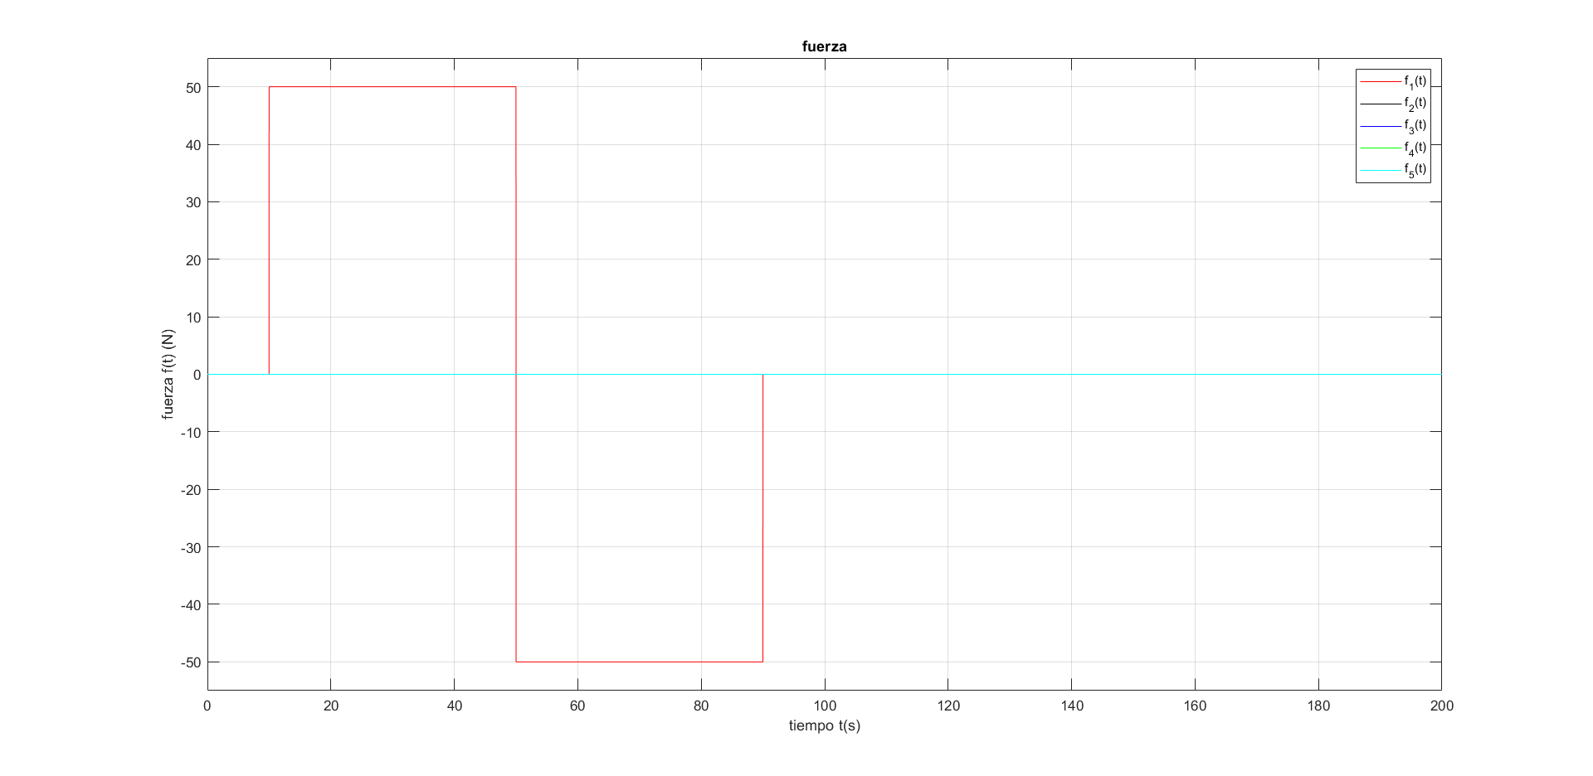

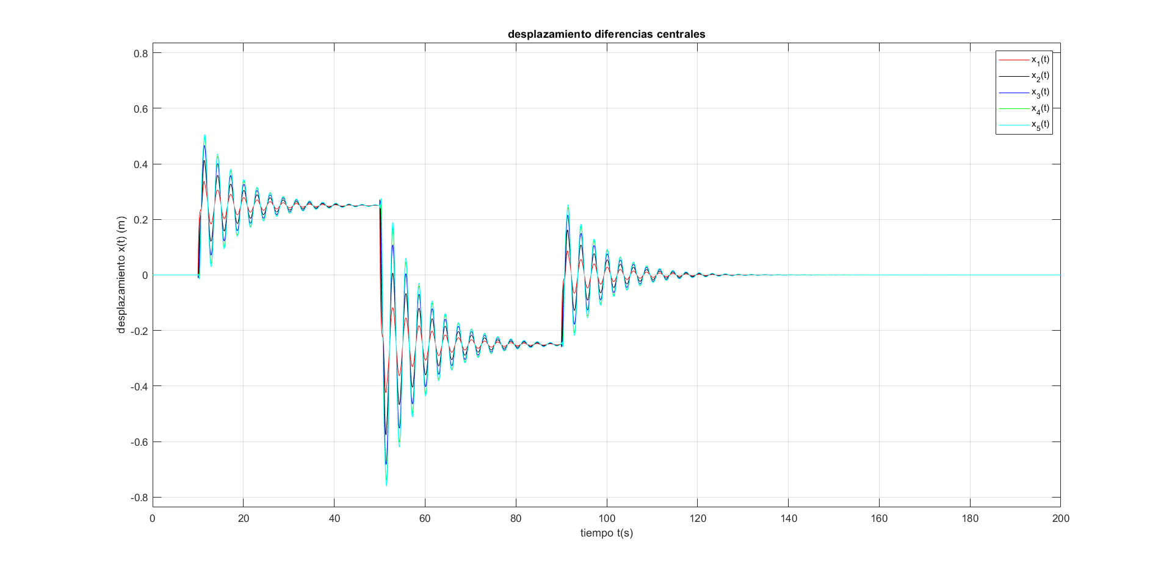

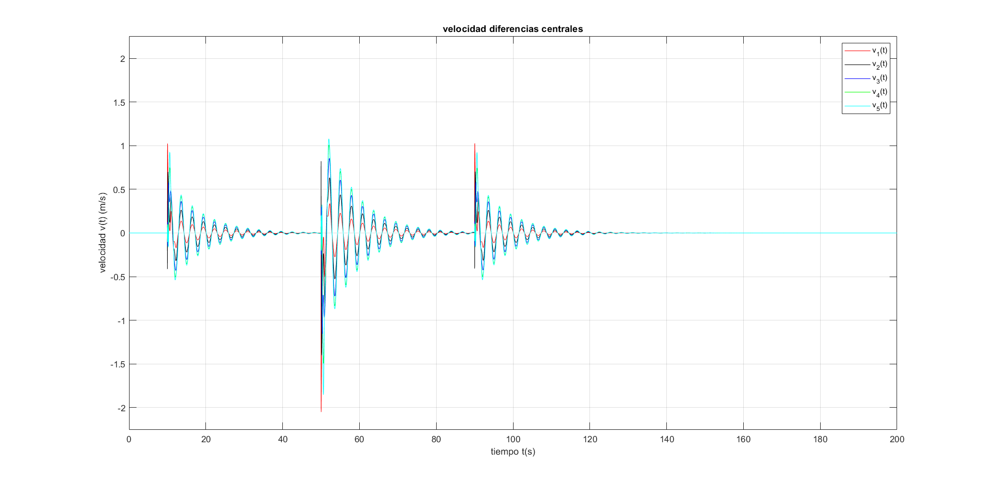

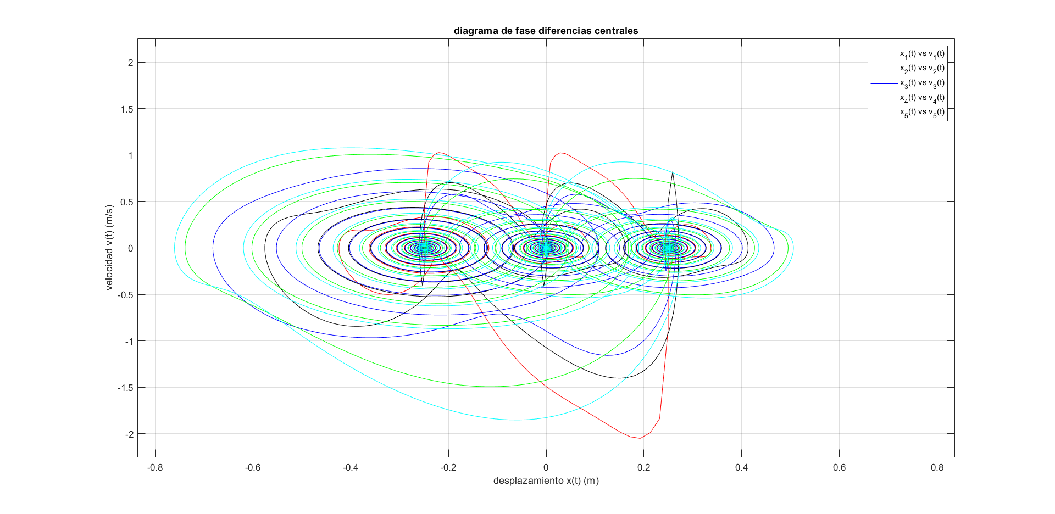

Ecuación Diferencial 3.2 (10pts)

Resuelva la ecuación diferencial ordinaria de segundo orden no lineal, con valores iniciales mediante el método de Euler, incluyendo, desplazamiento, velocidad, diagrama de fase y espacio de fase

$$y'' + δy' + βy^{3} + ω_{0}y =γcos(ωt + φ_{0})$$

$$y\left(0\right)=0.5$$
$$y^{'}\left(0\right)=-0.5$$

%% prog metodo de euler control 01 parte 3.2

clearvars;
close all;
clc;

%% incializacion

%ecuacion diferencial
% y'' + delta*y' + beta*y^3 + w0*y = gama*cos(w*t + phi0)

%uso de variable auxiliar
% y' = u
% u = y'
% y'' = -delta*y' - beta*y^3 - w0*y + gama*cos(w*t + phi0)
% u' = -delta*y' - beta*y^3 - w0*y + gama*cos(w*t + phi0)

%datos
delta = 1.0;
beta = 1.0;
w0 = -1.0;
gama = 1.0;
phi0 = 0.0;
w = 0.1;

%tiempo incial/final
tini = 0;
tfin = 200;

%valores inciales%
y0 = 0.5; %posición incial
u0 = -0.5; %velocidad incial u(0) = y'(0)

%incrementos
deltat = 0.0001;

%valores de xn por prelocalización
tn = tini:deltat:tfin; %valores de tn
Nn = length(tn); %tamanho de tn

%valores yn por prelocalización
yn = zeros(1,Nn); %incialmente lleno de ceros

%valores un por prelocalización
un = zeros(1,Nn); %incialmente lleno de ceros

%condicion incial de desplazamiento
yn(1) = y0; %condicion incial desplazamiento

%condicion inicial de velocidad
un(1) = u0; %condicion incial velocidad u(0) = y'(0)

%% solucion numérica
for n = 1:Nn-1
yn(n+1) = yn(n) + deltat*un(n);
un(n+1) = un(n) + deltat*( -delta*un(n) - beta*yn(n)^3 - w0*yn(n) + gama*cos(w*tn(n) + phi0) );
end;

%% espacio de fase

%desplazamiento
Lyini = -1.1*max(abs(yn));
Lyfin = 1.1*max(abs(yn));
dy = 0.01;

%velocidad
Luini = -1.1*max(abs(un));
Lufin = 1.1*max(abs(un));
du = 0.01;

%tiempo
Tini = -1.1*max(abs(un));
Tfin = 1.1*max(abs(un));
dt0 = 0.01;

%espacio de estados inciales
[y0,u0] = meshgrid(Lyini:dy:Lyfin,Luini:du:Lufin);

%tiempo
t0 = meshgrid(Lyini:dy:Lyfin,Luini:du:Lufin);

%aceleracion
v0 = -delta*u0 - beta*y0.^3 - w0*y0 + gama*cos(w*t0 + phi0);

%vector
figure(1)
quiver(y0,u0,u0,v0,'r'); %dibuja flechas 2D
title('espacio de fase');
xlabel('y(t) (m) ');
ylabel('dy(t)/dt (m/s)')
legend('espfase');
daspect([1 1 1]);
axis([ -1.1*max(abs(yn)) 1.1*max(abs(yn)) 1.1*min(un) 1.1*max(un) ]);
grid on;
box on;

%% resultados

figure(2)
plot(tn,yn,'k')
title('solucion euler desplazamiento');
xlabel('t (s) ')
ylabel('y(t) (m)');
legend(['y(t) \Deltat = ' num2str(deltat)])
axis([ tini tfin -1.1*max(abs(yn)) 1.1*max(abs(yn))]);
grid on;
box on;

figure(3)
plot(tn,un,'k')
title('solucion euler velocidad');
xlabel('t (s)')
ylabel('dy(t)/dt (m/s)')
legend(['dy(t)/dt \Deltat = ' num2str(deltat)])
axis([ tini tfin 1.1*min(un) 1.1*max(un) ]);
grid on;
box on;

figure(4)
plot(yn,un,'k')
title('diagrama de fase');
xlabel('y(t) (m) ');
ylabel('dy(t)/dt (m/s) ');
legend(['y(t) vs dy(t)/dt \Deltat = ' num2str(deltat)])
axis([ -1.1*max(abs(yn)) 1.1*max(abs(yn)) 1.1*min(un) 1.1*max(un) ]);
grid on;
box on;

figure(5)
quiver(y0,u0,u0,v0,'r'); %dibuja flechas 2D
hold on;
plot(yn,un,'k')
title('espacio de fase y diagrama de fase');
xlabel('y(t) (m)');
ylabel('dy(t)/dt (m/s)');
legend('espfase',['y(t) vs dy(t)/dt \Deltat = ', num2str(deltat)] );
daspect([1 1 1]);
axis([ -1.1*max(abs(yn)) 1.1*max(abs(yn)) 1.1*min(un) 1.1*max(un) ]);
grid on;
box on;

