Reading
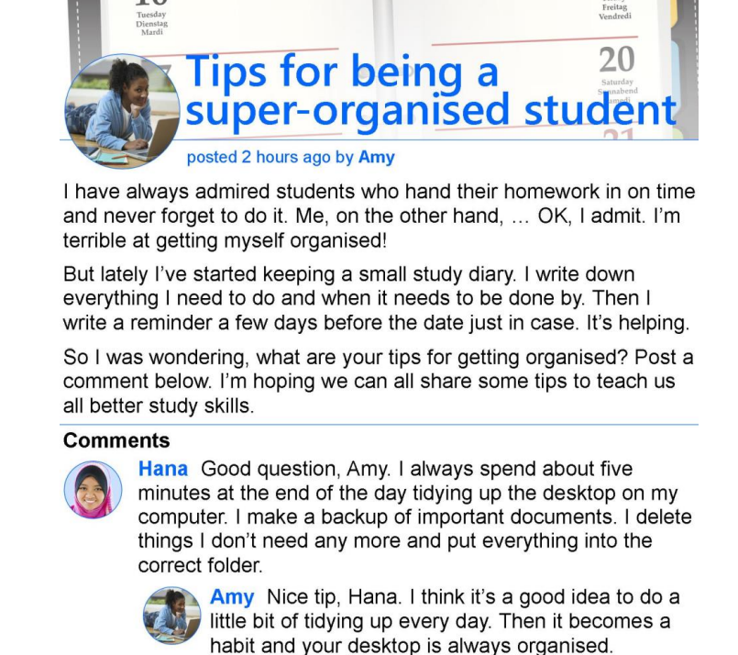
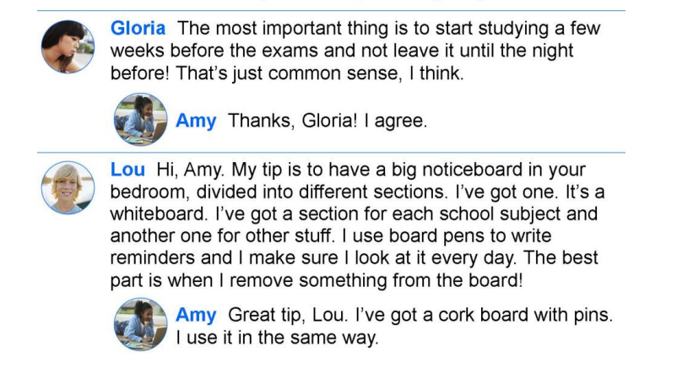

1. Check your understanding: true or false
Circle True or False for these sentences.

1. Amy is very good at handing in her homework on time. True False
2. Amy writes down the date she has to hand in her homework. True False
3. Hana tidies her computer desktop twice a day. True False
4. Amy thinks Hana’s tip is good. True False
5. Gloria thinks the date you start studying is important. True False
6. Lou thinks the best thing about having a noticeboard is using board pens. True False

2. Check your vocabulary: gap fill Write words to fill the gaps.
Amy is asking for 1 ______________ about organising school work. She keeps a 2 ______________ with a record of her homework. She also writes a 3 _______________ in case she forgets. Hana thinks it's important to keep your computer 4 _______________ clean and tidy. She deletes things she doesn’t need and puts her work into separate 5 _______________. Gloria says it's important to start studying in plenty of time and not to leave things until the night 6 _______________! Lou’s tip is to use a noticeboard, divided into sections for each 7 _______________. He thinks the best thing about this idea is the feeling he gets when he 8 _______________ an item!

Vocabulary
Match the vocabulary with the correct definition and write a–h next to the numbers 1–8.
1…….. advice a. nervous and worried
2…….. last but not least b. to be strongly attracted to doing something
3…….. to be tempted c. a good or full amount
4…….. anxious d. the act of doing something again
5…….. plenty e. an opinion or recommendation about what
someone should do
6…….. repetition f. a short walk around your local area

7…….. a stroll around the block g. to put something over something so that you
can’t see it
8…….. to cover something up h. an expression used before the last thing in a
list, to say that it is equally as important

Listening Section
I. Advice for exams: You will hear the teacher giving students advice for the exams and do the
exercises to practise and improve your listening skills. Listen and answer the questions below.

1. What does the teacher want the students to take?
2. What does the teacher suggest eating?
3. What should the study place have?
4. What should the students do if they feel stressed?
5. How long is the break that the teacher recommends?
6. What is the teacher sure that the students will do?

