Passive Voice
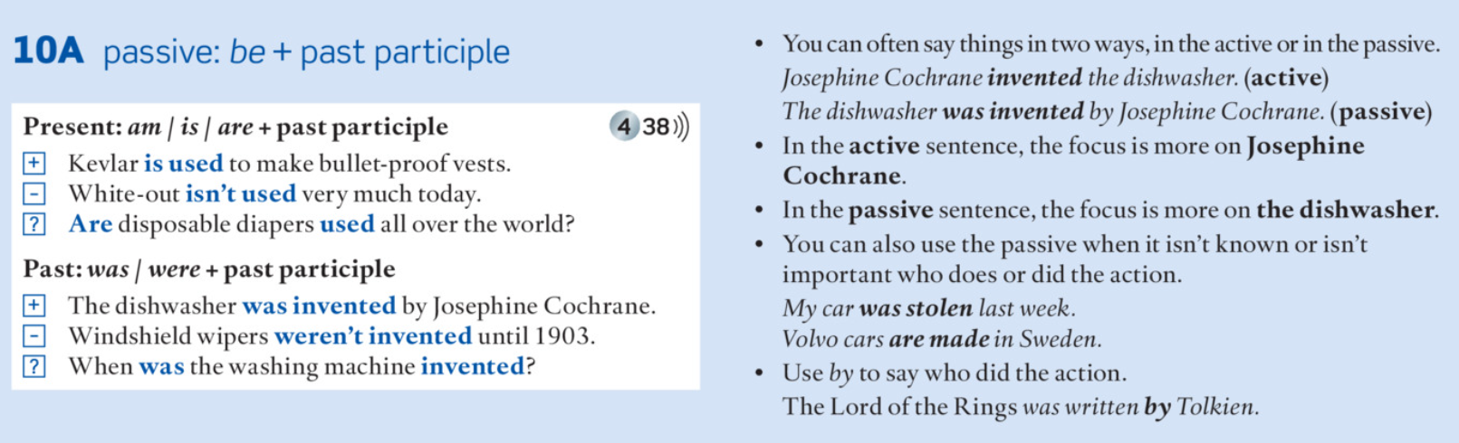

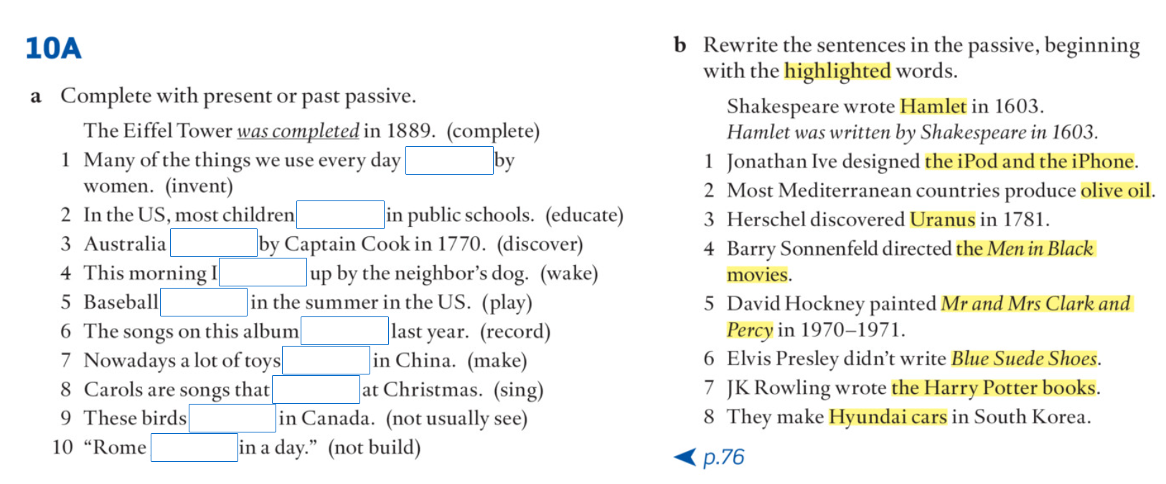

Taken from AEF 2, second edition.

